FACULTY OF INFORMATION TECHNOLOGY
IT PROJECT 700 | GROUP 55

EMERGEX
  - Centralized Student Accommodation & Secure Booking Application
FINAL INTEGRATED PROJECT REPORT
Complete SDLC documentation and implementation evidence
Supervisor: Thabiso | ThabisoA@richfield.ac.za | Semester 2, 2026
Student no. | Member | Email | Contact | Primary role
402308936 | Tristan Moses | 402308936@my.richfield.ac.za | 0828015082 | Project manager and frontend lead
402411668 | Reenesh Ramawthar | 402411668@my.richfield.ac.za | 0846041521 | Backend and quality engineering
402411227 | Joyce Kamalu | 402411227@my.richfield.ac.za | 0671075365 | Business analysis and documentation
402412304 | Novithan Naidoo | 402412304@my.richfield.ac.za | 0620829186 | Database and backend engineering
402413409 | Thingo Shezi | 402413409@my.richfield.ac.za | 0714299251 | UI/UX and frontend engineering
402111846 | Lungelo Ngwane | 402111846@my.richfield.ac.za | 0642534563 | Testing, deployment and support
Project lead baseline: Tristan Moses | Every member contributes and presents.

Document Control
Table 1. Document control
Field | Value
Document owner | Group 55
Version | 1.0 - assessment baseline
Prepared | 18 August 2026
Approval status | For supervisor review
Confidentiality | Academic project; demo data only
Repository | Group 55 - Completed Project/application

Academic Integrity and Contribution Statement
The report represents a unified group deliverable. The responsibilities shown on the administrative page identify primary owners, not exclusive authors. All six members are expected to review the final report, understand the implementation, participate in supervisor meetings and present their assigned section to the assessment panel.

Executive Summary
EMERGEX is a secure, centralized web application prototype for South African students seeking accommodation near tertiary institutions. The project responds to a long-standing supply and quality problem documented by the Department of Higher Education and Training, and to the practical difficulty of comparing trustworthy listings, obtaining timely landlord responses and managing deposit risk. The solution brings property discovery, verification evidence, booking status and a simulated deposit-hold lifecycle into one auditable workflow.
The implementation uses a LAMP architecture: Apache and PHP provide server-side application logic, MySQL/InnoDB enforces relational integrity, while HTML5, CSS3 and JavaScript deliver a responsive interface. Three user roles are implemented. Students search, filter, book, upload NSFAS evidence and confirm check-in. Landlords manage verified listings and respond to requests. Administrators review identities, properties and documents and monitor audit events. The prototype deliberately does not process real money; production escrow would require a regulated payment provider and formal legal review.
A hybrid SDLC is applied. Waterfall gates align the academic phases and approval dates, while Agile sprints support parallel delivery across frontend, backend, database, analysis, documentation and testing work. The final package contains the runnable application, schema, seed data, installation guide, security checks, phase reports, this integrated report and an assessment presentation.

Table of Contents
Document Control 3
Academic Integrity and Contribution Statement 3
Executive Summary 3
Abbreviations and Key Terms 6
Project Purpose and Direction 7
Purpose of the Project 7
Objectives 7
Implementation Language and Platform 8
SDLC Model 8
Planning Phase 10
Identification of Need 10
Preliminary Investigation 11
Feasibility Study 11
Project Charter and Scope 11
Work Breakdown and Responsibilities 13
Project Schedule 14
Risk Management 16
Communication, Quality and Change Control 16
Software Requirements Specification Summary 17
Software Engineering Paradigm 18
Analysis Phase 19
Information-Gathering Methodology 19
Analysis of the Existing System 19
Weaknesses and Root Causes 20
Data Analysis: Integrity and Constraints 20
Analysis of the Proposed System 21
Functional Requirements 22
Non-Functional Requirements 23
Data Modelling 24
Requirements Validation and Traceability 25
System Design Phase 26
Description of the Proposed System 26
Architectural Design 27
Hardware and Network Architecture 28
Class and Behaviour Design 29
Physical and Database Design 30
Normalization 32
Program Design and Pseudocode 32
Interface Design 33
Input Validation Design 33
Output and Report Design 34
Security and Backup Design 34
Design Test Cases 35
Implementation Phase 36
Implementation Overview 36
Coding Standards and Efficiency 36
Representative Code Segments 37
Error Handling and Validation 37
Installation 38
Operational Demonstration Script 38
Testing and Evaluation 40
Testing Strategy 40
Environment and Evidence Status 41
Detailed Test Register 42
Static Security Check Results 42
Defect Management 43
Evaluation of Results 43
System Security Measures 44
Database and Data Security 44
User Profiles and Access Rights 44
POPIA-Oriented Privacy Design 44
Project Cost Estimation 46
Economic Benefit Model 46
Reports and Sample Layouts 48
Future Scope and Enhancement 49
Maintenance and Configuration Management 49
Bibliography and Source Register 50
Glossary 51
Meeting and Review Templates 52
Final Submission Checklist 53

Abbreviations and Key Terms
Table 2. Abbreviations used in the report
Abbreviation | Meaning
API | Application Programming Interface
CRUD | Create, Read, Update and Delete
CSRF | Cross-Site Request Forgery
DFD | Data-Flow Diagram
ERD | Entity-Relationship Diagram
LAMP | Linux, Apache, MySQL and PHP
NSFAS | National Student Financial Aid Scheme
OWASP | Open Worldwide Application Security Project
PDO | PHP Data Objects
PERT | Program Evaluation and Review Technique
POPIA | Protection of Personal Information Act
RBAC | Role-Based Access Control
SDLC | Systems Development Life Cycle
SRS | Software Requirements Specification
UAT | User Acceptance Testing
WBS | Work Breakdown Structure
XSS | Cross-Site Scripting

PROJECT PROPOSAL

Project Purpose and Direction
This chapter defines the problem, intended value, technology choice and SDLC model approved as the foundation for subsequent work.

Purpose of the Project
South African tertiary institutions face a persistent student-housing capacity challenge. The 2011 ministerial review estimated a residence-bed shortage of 195,815 against recommended capacity targets, while a later DHET address described a projected university shortage of 216,000 beds and a separate immediate need of approximately 100,000 TVET beds [1][2]. Capacity alone does not solve the student journey: available rooms must also be discoverable, comparable, legitimate and responsive to a time-sensitive academic calendar.
EMERGEX centralizes this journey. It allows a student to search verified listings by city, suburb, nearby institution, price, NSFAS status and Instant Book availability. Each approved listing presents consistent rent, deposit, availability, amenities and visual-evidence fields. The booking workflow records who requested a room, the required move-in date, landlord decision, deposit status and check-in confirmation. Administrators can verify landlords, properties and uploaded evidence and can inspect an audit history of critical actions.
The prototype is positioned as a safer and more transparent alternative to fragmented social-media searches and informal direct payments. It does not claim that every competing marketplace lacks verification; DigsConnect, for example, currently advertises verified listings, in-platform or WhatsApp-led contact, and a landlord facilitation model [4][5]. EMERGEX differentiates its academic design through a single visible booking state machine, mandatory visual-evidence categories, an explicit 12-hour response target, an Instant Book path and a deposit-hold simulator tied to check-in confirmation.
Ethical and legal boundary
The academic system records simulated escrow statuses only. No real money is collected, held or transferred. Production release would require a licensed payment service provider, legal advice, formal POPIA governance and penetration testing.

Objectives
Table 3. Project objectives and success measures
Objective | Measurable success indicator
Centralize trusted discovery | A student can search and filter all published verified properties from one interface.
Reduce uncertainty | Every published property contains consistent location, price, deposit, amenities, availability and visual-evidence indicators.
Accelerate placement | Instant Book approves eligible requests immediately; standard requests store a 12-hour response deadline.
Demonstrate deposit protection | The prototype records not-paid, held, released and refunded states without processing funds.
Protect access | Student, landlord and administrator operations are restricted on the server by role and ownership.
Preserve evidence | Critical registration, booking, verification and escrow actions create timestamped audit records.
Support assessment | The system, documentation, test design and presentation trace directly to the five rubric phases.

Implementation Language and Platform
The application is implemented with PHP 8, MySQL/MariaDB, Apache, HTML5, CSS3 and unobtrusive JavaScript. PHP was selected because the course concept explicitly targets a LAMP/XAMPP environment and because it offers built-in session management, password hashing, file handling and PDO database access. MySQL/InnoDB provides foreign keys, check constraints, transactions and indexes required by the booking and escrow state model. The presentation tier remains standards-based and does not depend on a large client framework, reducing local setup complexity.
Table 4. Technology selection rationale
Layer | Selection | Rationale
Client | HTML5, CSS3, JavaScript | Responsive, accessible and easy to demonstrate on desktop or mobile without a build step.
Server | Apache + PHP 8 | Compatible with XAMPP; supports sessions, routing, uploads, validation and secure password APIs.
Data | MySQL / MariaDB with InnoDB | Relational integrity, transactions, indexes and broad academic familiarity.
Local environment | XAMPP on Windows | Repeatable classroom installation and one control panel for Apache and MySQL.
Testing | PHP security checks plus manual/system cases | Provides static control evidence and repeatable role-based acceptance scenarios.

SDLC Model
A hybrid Waterfall-Agile model is used. Waterfall provides the macro structure because the supervisor must approve sequential academic phases: proposal, planning, analysis, system design and implementation. Entry and exit criteria prevent unapproved scope from silently flowing into code. Within each approved phase, Agile execution divides the work into short sprints and component ownership. This allows frontend, backend, database, documentation and testing tasks to progress concurrently while still converging at scheduled integration reviews.
Table 5. Hybrid SDLC governance
Waterfall gate | Agile activity inside the gate | Exit evidence
Proposal | Concept review and feasibility spike | Approved purpose, stack and SDLC
Planning | Backlog refinement, estimates and risk review | SRS, WBS, Gantt, PERT and baseline
Analysis | Interviews, competitor review and model iteration | Validated functional/non-functional requirements
Design | Architecture, schema, UI and threat-model workshops | Design package and traceability review
Implementation | Feature sprints, integration and defect triage | Runnable build, tests, installation package

The approach balances predictability with learning. Requirements that affect the academic scope are controlled at phase gates, while implementation details may be refined inside sprints when tests or stakeholder feedback reveal a better solution. Any material scope, schedule or security change is recorded in the change log and reviewed by the project lead and supervisor.

PHASE 2

Planning Phase
Planning converts the approved concept into a feasible, scheduled and testable delivery baseline.

Identification of Need
The need is for a trustworthy student-accommodation workflow that is usable during high-pressure registration periods. The primary user must be able to find available rooms near an institution, understand the complete financial commitment, establish whether the property is verified or NSFAS-accredited, and receive a timely decision. Landlords need qualified enquiries and an organized response queue. Administrators need evidence-based verification and traceable interventions rather than informal approval through messages or spreadsheets.
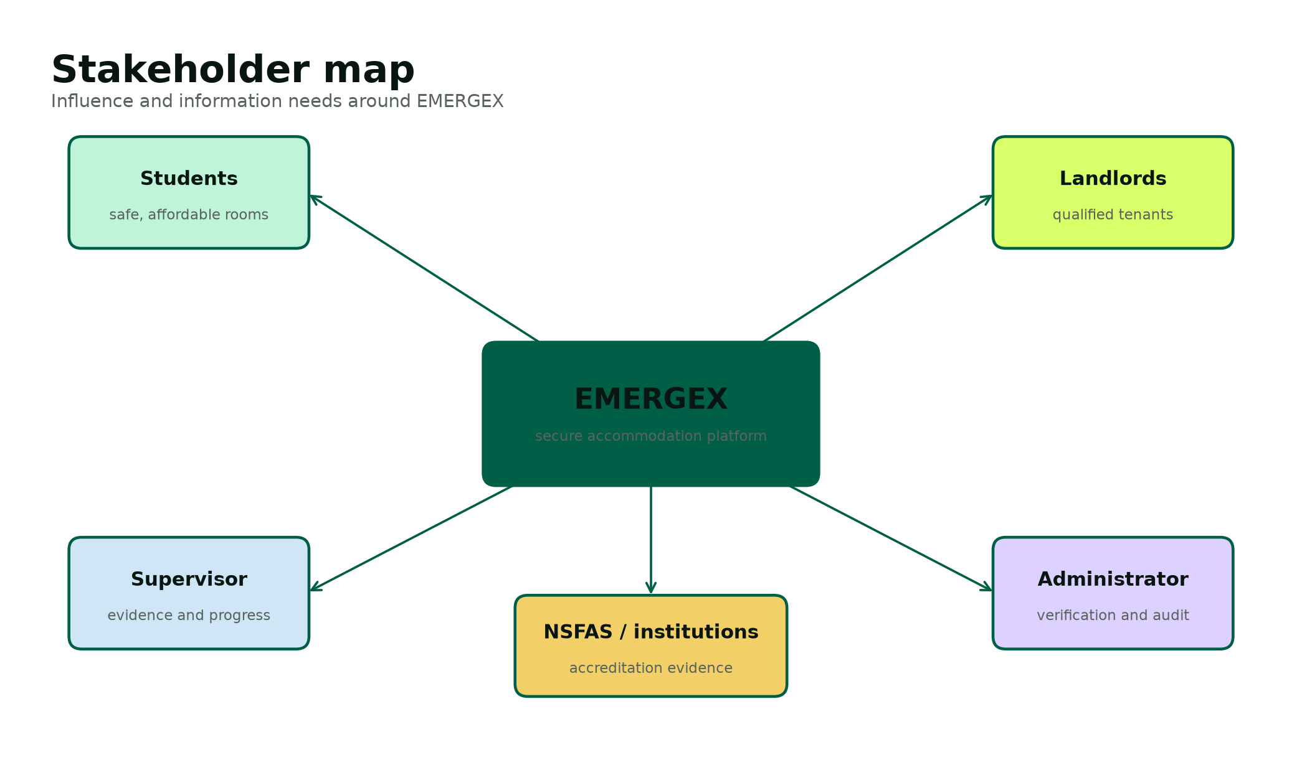
Figure 1. Stakeholder influence and information needs.
Table 6. Stakeholder register
Stakeholder | Interest | Influence | Information need | Engagement
Students | Safe, affordable and available accommodation | High | Price, distance, accreditation, visual proof, booking state | Usability reviews and acceptance tests
Landlords | Occupancy and credible applicants | High | Student request, move-in date, response deadline, deposit milestone | Workflow demos and dashboard review
Administrator | Platform trust and compliance | High | Verification queue, uploaded evidence and audit history | Weekly control review
Supervisor | Academic feasibility and evidence | High | Phase outputs, progress, risks and contribution | Scheduled reviews and approval gates
NSFAS / institutions | Accredited placement | Medium | Accreditation status and supporting evidence | Requirements validation; no live integration in prototype
Group members | Fair contribution and successful delivery | High | Backlog, owners, blockers and quality criteria | Twice-weekly stand-up and recorded minutes

Preliminary Investigation
The preliminary investigation combined the semester project guidelines, the existing Group 55 proposal, the EMERGEX pitch notes, official public information and an inspection of current accommodation marketplace behaviour. The investigation identified five recurring gaps to address in the prototype: fragmented discovery, uneven listing detail, uncertain verification, slow or invisible response status, and unsafe deposit behaviour outside a controlled workflow.
Table 7. Preliminary findings
Finding | Evidence or observation | Design response
Housing demand exceeds institutional supply | DHET reports document significant university and TVET accommodation shortfalls [1][2]. | Support private and institutional listings in a common search model.
Accreditation matters for funded students | NSFAS states that funded students should use accredited accommodation and that unaccredited providers may not be paid [3]. | Store and visibly filter NSFAS accreditation; require administrator review.
Existing marketplaces already provide useful search and contact | DigsConnect describes verified listings, search and direct contact [4]. | Do not copy blindly; focus differentiation on transparent states, visual evidence and response timing.
Landlord economics affect adoption | DigsConnect terms describe a fixed facilitation fee following confirmed tenancy [5]. | Document a lower-friction prototype model; defer final commercial pricing to validation.
Personal documents create privacy risk | POPIA governs lawful and secure processing of personal information [6]. | Collect the minimum, restrict access, validate uploads and define deletion expectations.

Feasibility Study
Table 8. Feasibility assessment
Dimension | Assessment | Conclusion / control
Technical | The team can build the required workflows with PHP, MySQL, HTML/CSS and JavaScript. XAMPP supports local deployment. Payment and identity integrations are beyond a safe student prototype. | Feasible when escrow and external integrations are simulated behind clear interfaces.
Operational | Students and landlords already use web and mobile channels. The workflow reduces informal hand-offs but requires administrator verification capacity. | Feasible with simple onboarding, status labels and an administrator queue.
Economic | The academic build uses open-source software and existing student devices. Production costs would be dominated by skilled labour, security, hosting and support. | Feasible for assessment; production requires staged funding and a validated revenue model.
Schedule | Five fixed due dates constrain the order of evidence. Parallel sprint work is needed between phase gates. | Feasible with the WBS, critical path, weekly integration and scope freeze after design.
Legal / ethical | POPIA, consumer law, property practice rules and payment regulation may apply. Real document and money handling would be high risk. | Prototype uses demo data and simulated funds; production requires professional compliance review.

Project Charter and Scope
Project charter
Deliver a demonstrable LAMP web application and complete SDLC evidence for Group 55 by 9 November 2026. The product shall help students discover verified accommodation, submit or instantly confirm a booking, simulate a protected deposit and confirm check-in, while landlords and administrators manage their responsibilities through role-specific dashboards.

Table 9. Scope boundary
In scope | Out of scope
Student, landlord and administrator registration/authentication | Real payment collection, custody, settlement or refunds
Verified property search, filters and rich listing details | Live NSFAS, university, identity-provider or bank integration
Standard booking with 12-hour response deadline | Legally binding digital lease execution
Instant Book for approved properties | Production-grade chat, SMS or WhatsApp delivery
Escrow lifecycle simulator and audit records | Native mobile applications
Validated demo document upload and review | Public production hosting with real personal documents
MySQL schema, seed data, installation and tests | Automated property inspections and legal accreditation decisions

Table 10. Key assumptions and constraints
Type | Statement | Planning response
Assumption | All six members can access Windows, XAMPP, Word and MS Teams. | Keep local setup documented and maintain one shared baseline.
Assumption | Supervisor feedback is available within approximately three working days. | Submit early enough to preserve correction time.
Constraint | Final academic due dates cannot move. | Treat phase dates as hard milestones and protect the critical path.
Constraint | No licensed payment or identity service is available. | Use explicit simulators and demo evidence only.
Constraint | The final report must be approximately 50-80 pages, excluding code. | Use a unified evidence-based report with numbered figures and tables.
Constraint | Every member must contribute and present. | Assign primary ownership, peer review and speaking sections.

Work Breakdown and Responsibilities
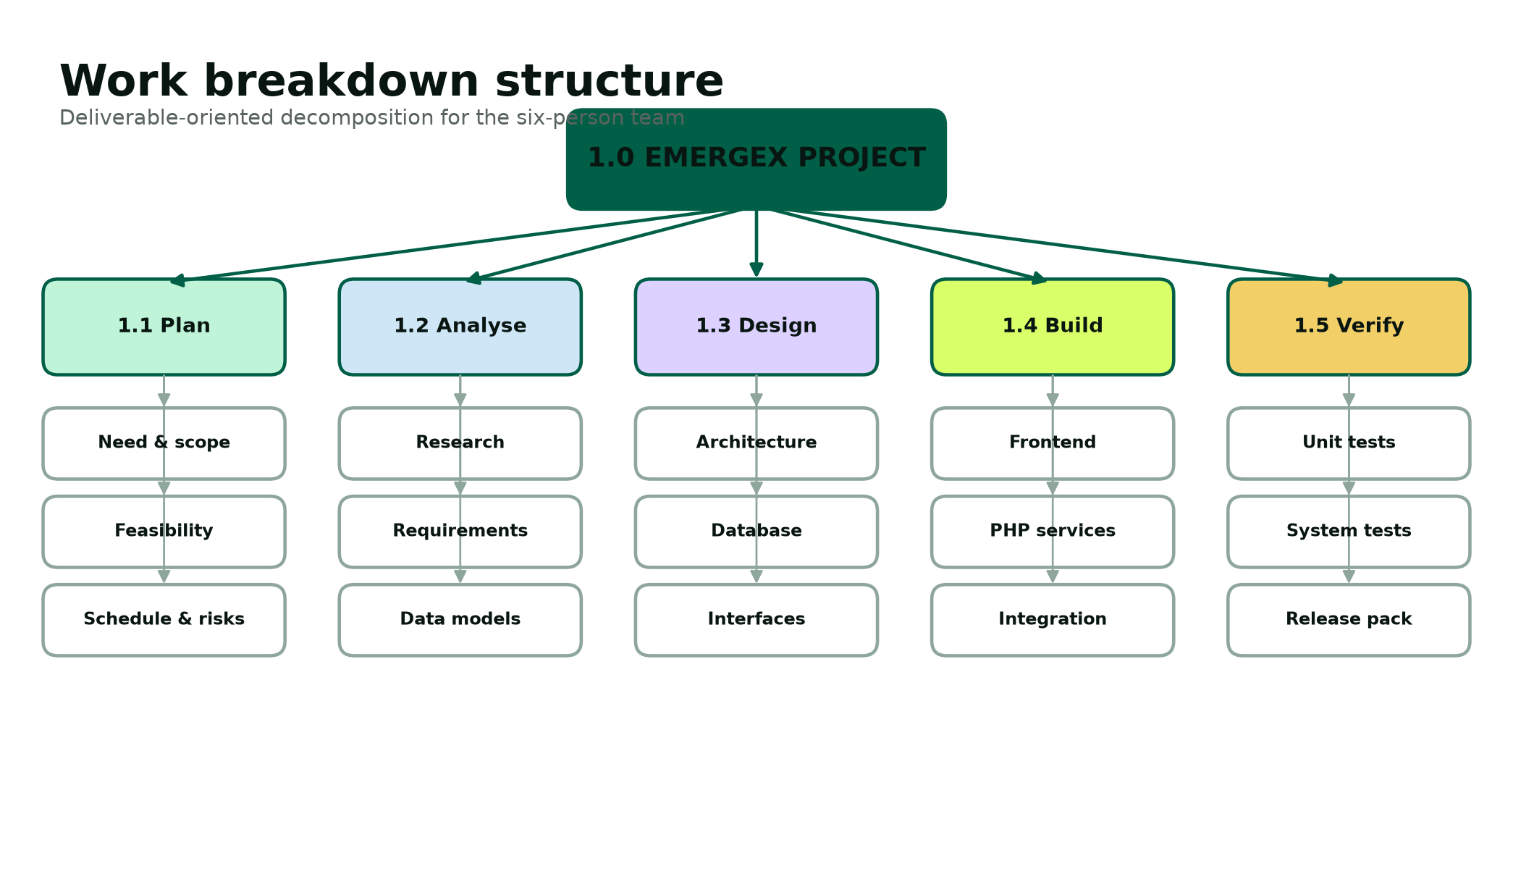
Figure 2. Deliverable-oriented work breakdown structure.
Table 11. Responsibility assignment matrix
Deliverable | Accountable | Responsible | Consulted / reviewer
Project baseline and supervisor coordination | Tristan | Tristan, Joyce | All members
Requirements and analysis | Joyce | Joyce, Lungelo | Tristan, Reenesh
UI/UX and responsive frontend | Thingo | Thingo, Tristan | Joyce, Lungelo
Database and backend services | Reenesh | Reenesh, Novithan | Tristan, Lungelo
Security and access control | Reenesh | Reenesh, Novithan | Lungelo
Testing and defect evidence | Lungelo | Lungelo, Reenesh | All feature owners
Documentation integration | Joyce | Joyce, Tristan | All members
Deployment and presentation | Tristan | Lungelo, Thingo | All members

Project Schedule
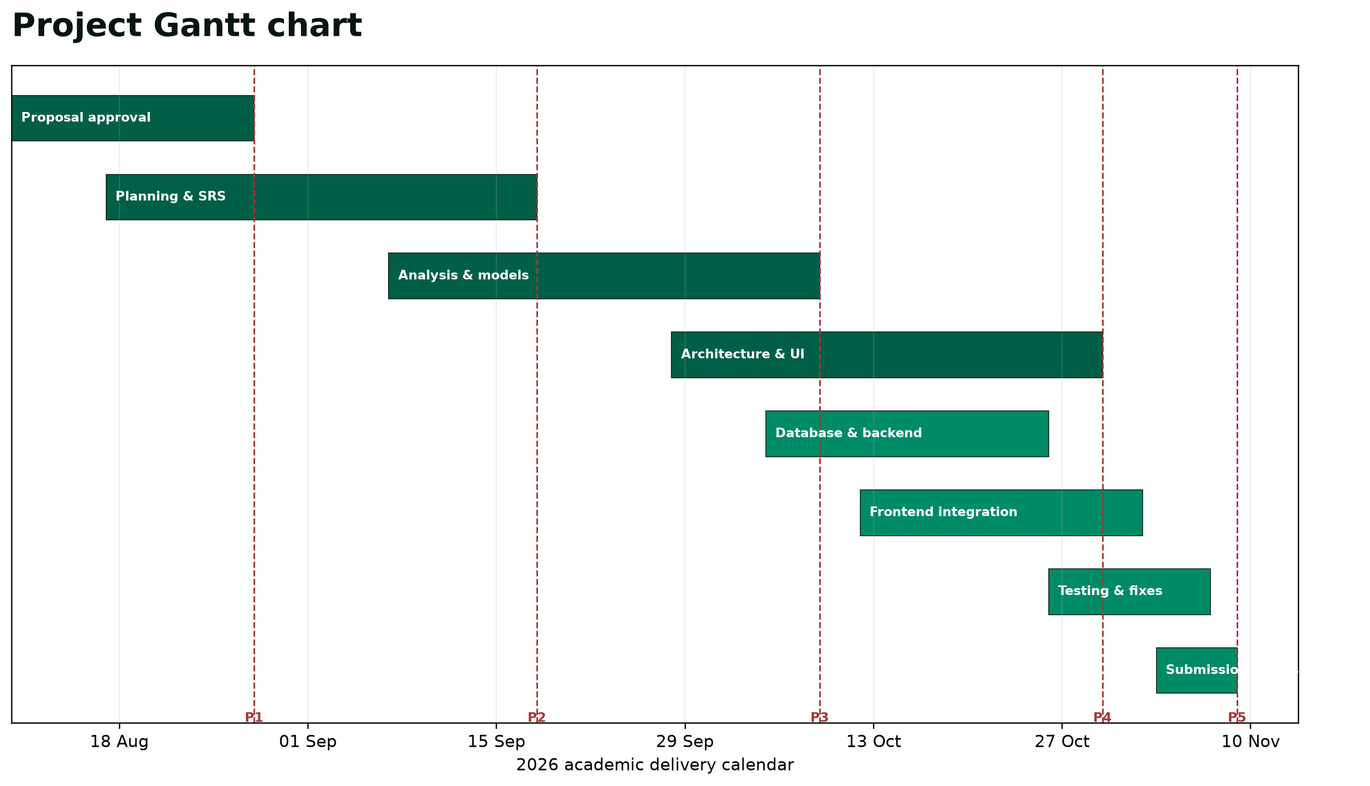
Figure 3. Gantt schedule aligned to the official semester deadlines.
Table 12. Milestone baseline
Milestone | Due date | Acceptance evidence | Owner
Phase 1 - Proposal | 28 Aug 2026 | Purpose, implementation language and SDLC approved | Tristan
Phase 2 - Planning | 18 Sep 2026 | Need, feasibility, WBS, Gantt, PERT, SRS and models | Joyce
Phase 3 - Analysis | 09 Oct 2026 | Methods, existing/proposed analysis and requirements | Joyce
Phase 4 - System design | 30 Oct 2026 | Architecture, database, pseudocode, UI and security design | Reenesh
Phase 5 - Implementation | 09 Nov 2026 | Code, test evidence, installation and final package | Lungelo

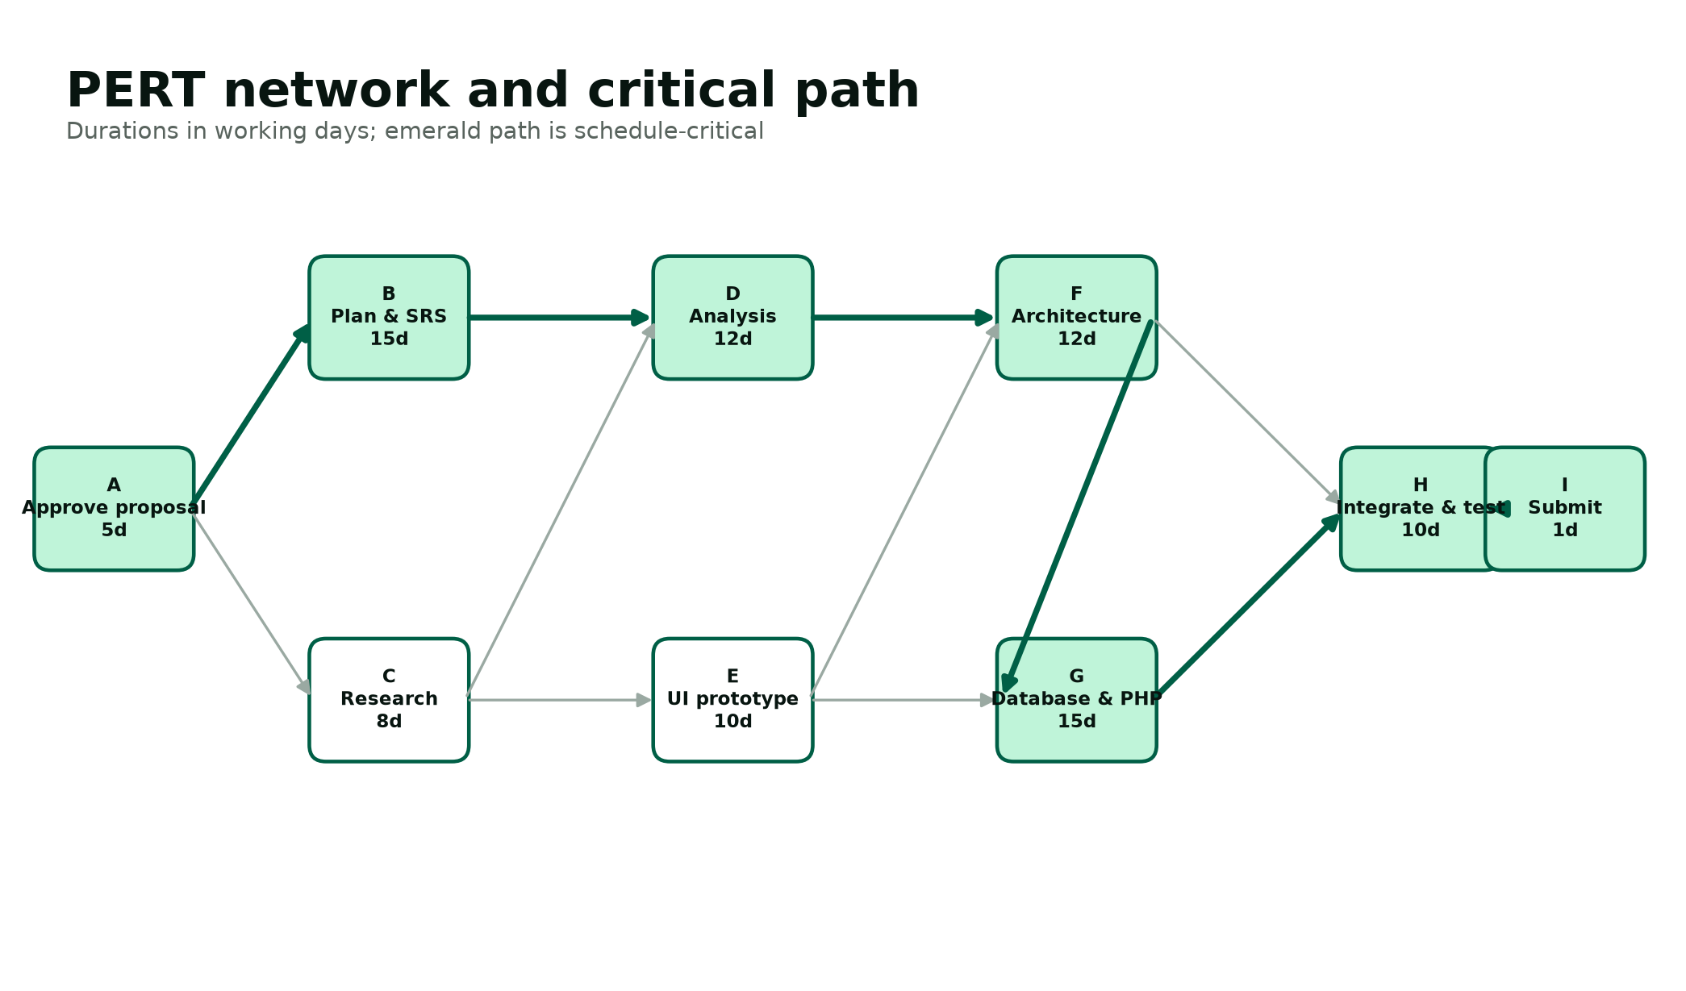
Figure 4. PERT network and critical path used for schedule control.
The critical path runs from proposal approval through planning, analysis, architecture, database/backend integration, system testing and submission. Activities such as research and early UI prototyping have limited float and may proceed in parallel, but their outputs must merge before the architecture and integration gates. If a critical activity slips, the team first reallocates members and reduces non-essential polish; it does not remove security controls, data integrity or required assessment evidence.

Risk Management
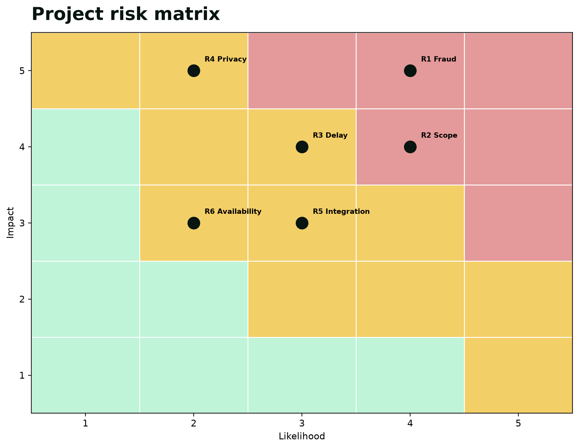
Figure 5. Likelihood-impact view of the principal project risks.
Table 13. Risk register
ID | Risk | L | I | Preventive control | Contingency / owner
R1 | Fraudulent property or landlord evidence | 4 | 5 | Administrator verification and visible status; audit events | Suspend listing and preserve evidence / Admin
R2 | Scope exceeds semester capacity | 4 | 4 | Freeze MVP after design; classify future features | Defer integrations and retain simulator / Project lead
R3 | Critical-path delay | 3 | 4 | Weekly milestone review; parallel ownership | Reassign members and shorten polish cycle / Lead
R4 | Personal-information exposure | 2 | 5 | Demo data only; minimal collection; restricted uploads | Delete affected data and investigate / Security lead
R5 | Frontend/backend integration defect | 3 | 3 | Shared data contract and early vertical slice | Rollback to last verified build / Backend lead
R6 | Member availability or contribution gap | 2 | 3 | Visible owners, meeting minutes and peer review | Rebalance tasks and inform supervisor / Lead
R7 | Database corruption or accidental reset | 2 | 4 | Schema in source control and backup procedure | Restore latest SQL backup / Database lead
R8 | Presentation failure or network interruption | 2 | 3 | Local deck, offline demo screenshots and rehearsal | Use recorded walkthrough / Presentation lead

Communication, Quality and Change Control
Table 14. Communication plan
Forum | Frequency | Participants | Purpose / record
Team stand-up | Twice weekly | All members | Progress, blockers, next actions; brief minutes
Integration review | Weekly | Developers, QA, analyst | Demonstrate vertical slice and log defects
Supervisor review | Per phase and when blocked | Project lead plus relevant owners | Approval, scope guidance and feedback record
Document peer review | Before every submission | Two reviewers not primary author | Rubric traceability, consistency and source check
Presentation rehearsal | Twice before panel | All members | Timing, handovers, individual questions and backup plan

A change request states the reason, affected requirement, scope impact, schedule impact, data/security effect, proposed decision and owner. The project lead may approve minor changes that do not alter a phase baseline. Material changes require the group and supervisor. Every accepted change updates the requirement traceability matrix and relevant test cases.

Software Requirements Specification Summary
The SRS is the controlled agreement between the approved need and the design. Requirements use stable identifiers so implementation and tests can be traced without relying on page location. The full functional and non-functional specification is developed in the analysis chapter; the planning baseline establishes user classes, interfaces and priority.
Table 15. User classes
User class | Characteristics | Primary goals | Privilege boundary
Visitor | Unauthenticated browser user | Browse published listings and understand safety process | Cannot book, upload or access dashboards
Student | Authenticated tertiary student | Search, book, track deposit state, upload demo NSFAS proof | Can access only own bookings and documents
Landlord | Authenticated accommodation provider | Manage own listings and respond to their booking requests | Cannot verify self or view unrelated properties
Administrator | Trusted operational reviewer | Verify entities, review documents and inspect audit events | Cannot impersonate users; actions are audited

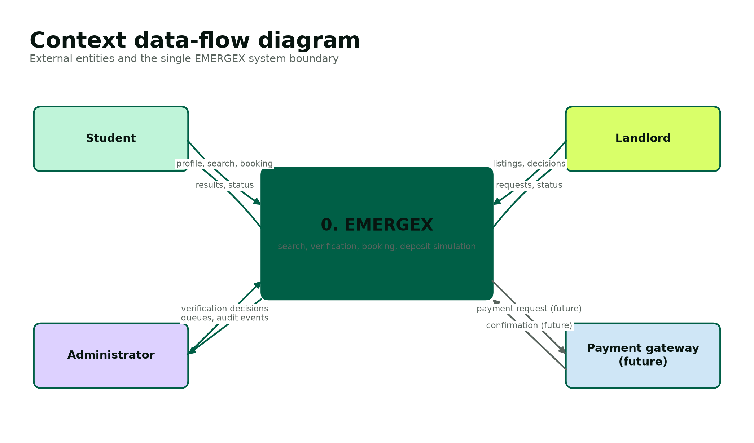
Figure 6. Context model included in the planning baseline.

Software Engineering Paradigm
The implementation follows a modular, transaction-oriented web paradigm. Presentation, application and data responsibilities are separated. Reusable bootstrap functions centralize database access, escaping, session security, CSRF, role enforcement and audit recording. Each public page performs one coherent workflow and applies server-side ownership checks. Database transactions protect multi-table booking and escrow changes. This structure is deliberately simpler than a large framework but preserves the design principles needed for maintainability and testability.

PHASE 3

Analysis Phase
Analysis validates what the system must do, why current approaches are insufficient and which data and quality rules govern the proposed solution.

Information-Gathering Methodology
The analysis uses triangulation rather than a single source. Documentary analysis covers the module guidelines, Group 55 concept notes, official DHET and NSFAS material, applicable privacy legislation and public competitor information. Structured observation maps the visible steps of searching, enquiring and confirming accommodation. Participatory workshops convert the six team members into representative student, landlord, administrator, analyst, developer and tester viewpoints. Semi-structured interview guides are prepared for future validation with real users, but no unrecorded interview claim is presented as completed evidence in this report.
Table 16. Fact-finding methods
Method | Participants / source | Questions addressed | Output
Document review | Guidelines, proposal, pitch and official sources | What is required academically, operationally and legally? | Rubric map, constraints and evidence register
Structured observation | Public accommodation search and booking journeys | Where does a user change channel, wait or lose status visibility? | Current-state process and weakness list
Participatory workshop | Six group members using assigned stakeholder roles | Which tasks, states and exceptions matter? | Use cases, business rules and priorities
Interview guide | Planned students and landlords | What information builds trust and what causes abandonment? | Validation script for supervisor-approved research
Prototype walkthrough | Team and supervisor | Can each role complete the critical path? | Usability issues, defects and acceptance decisions

Analysis of the Existing System
The relevant current environment is not one system. It includes institution residence processes, private-provider websites, accommodation marketplaces, social-media groups, direct messaging and bank transfers. A student often discovers a property in one channel, requests details in another, signs or sends documents by email and pays directly. Each channel may be individually familiar, but the overall state of the booking is difficult to audit.
DigsConnect is treated as the principal marketplace comparator because its public material describes a South African student-accommodation search and enquiry service, verified listings, direct communication and a booking/facilitation model [4][5]. The analysis does not claim that the competitor is unsafe or featureless. Instead it uses the publicly visible workflow as a baseline and asks how an academic prototype could make evidence categories, response deadlines and booking/deposit states more explicit in one interface.
Table 17. Current-state process analysis
Step | Typical channel | Observed limitation | Consequence
Discover property | Marketplace, social media or institution list | Inventory and filters vary by channel | Students repeat searches and comparisons
Verify legitimacy | Profile, messages, reviews or manual documents | Evidence standards and reviewer identity may be unclear | Trust depends on informal judgement
Inspect property | Photos, visit or separate video link | Media may be incomplete or inconsistent | Remote students cannot assess layout confidently
Enquire | Form, chat, email or WhatsApp | No common response timer or status vocabulary | Student may wait while alternatives disappear
Confirm tenancy | Message and lease exchange | Availability may not update across channels | Double-handling and stale inventory risk
Pay deposit | Direct bank transfer or external gateway | Payment may occur before safe check-in evidence | Dispute and fraud exposure
Move in | Offline inspection and handover | Booking system may not record condition or confirmation | Weak release and dispute evidence

Weaknesses and Root Causes
Table 18. Weakness analysis
Weakness | Root cause | Requirement response
Fragmented journey | Search, communication, evidence and payment are separate | Provide one booking record with visible lifecycle states.
Uneven listing quality | Free-form listings do not enforce a complete evidence set | Require structured attributes and visual-evidence categories before publication.
Slow response uncertainty | Enquiry systems may show that a message was sent but not an operational deadline | Store a 12-hour response deadline and prioritize pending requests.
Deposit exposure | Direct transfer is disconnected from verified check-in | Use a simulated hold/release lifecycle and document production PSP boundary.
Accreditation ambiguity | Status may be stated without stored review evidence | Allow administrator review and visible NSFAS filter.
Excessive personal-data handling | Documents are shared across uncontrolled channels | Minimize data, restrict uploads, validate type and define retention.
Weak accountability | Critical decisions are not consistently timestamped | Write audit events for registration, verification, booking and escrow changes.

Data Analysis: Integrity and Constraints
The central analytical decision is to treat a booking as a controlled stateful transaction, not merely a message. Rent and deposit values are copied into the booking at creation time so later property price changes do not rewrite the historical agreement. Each escrow simulator record has a one-to-one relationship with a booking. Ownership links restrict a landlord to properties they own and a student to bookings they created. Verification timestamps are separate from published status so the system can distinguish review evidence from presentation state.
Table 19. Business data rules
Rule ID | Rule | Enforcement
BR-01 | Every user has one unique email address. | UNIQUE database constraint and registration error handling.
BR-02 | A student number is required for student registration and is unique when present. | Server validation plus nullable UNIQUE column.
BR-03 | Only active accounts may authenticate. | Login query and current-user lookup check status.
BR-04 | Only verified, published properties appear in search. | Search WHERE clause requires status and verified_at.
BR-05 | Rent must be positive and deposit cannot be negative. | Database CHECK constraints plus numeric input validation.
BR-06 | A booking belongs to one student and one property. | Foreign keys and ownership queries.
BR-07 | Each booking has exactly one escrow simulator record. | Unique booking_id in escrow_transactions; transaction at booking creation.
BR-08 | Only pending standard requests may be approved or rejected. | Server-side status transition guard.
BR-09 | Deposit hold is available only after approval. | Student dashboard checks booking and escrow states.
BR-10 | Release occurs only after a held deposit and check-in confirmation. | Transactional state guard and audit event.
BR-11 | Uploaded demo files must be PDF, JPEG or PNG and at most 5 MB. | Fileinfo MIME allow-list, size check and random stored name.
BR-12 | Only administrators verify landlords, properties and documents. | Role gate and audited update actions.

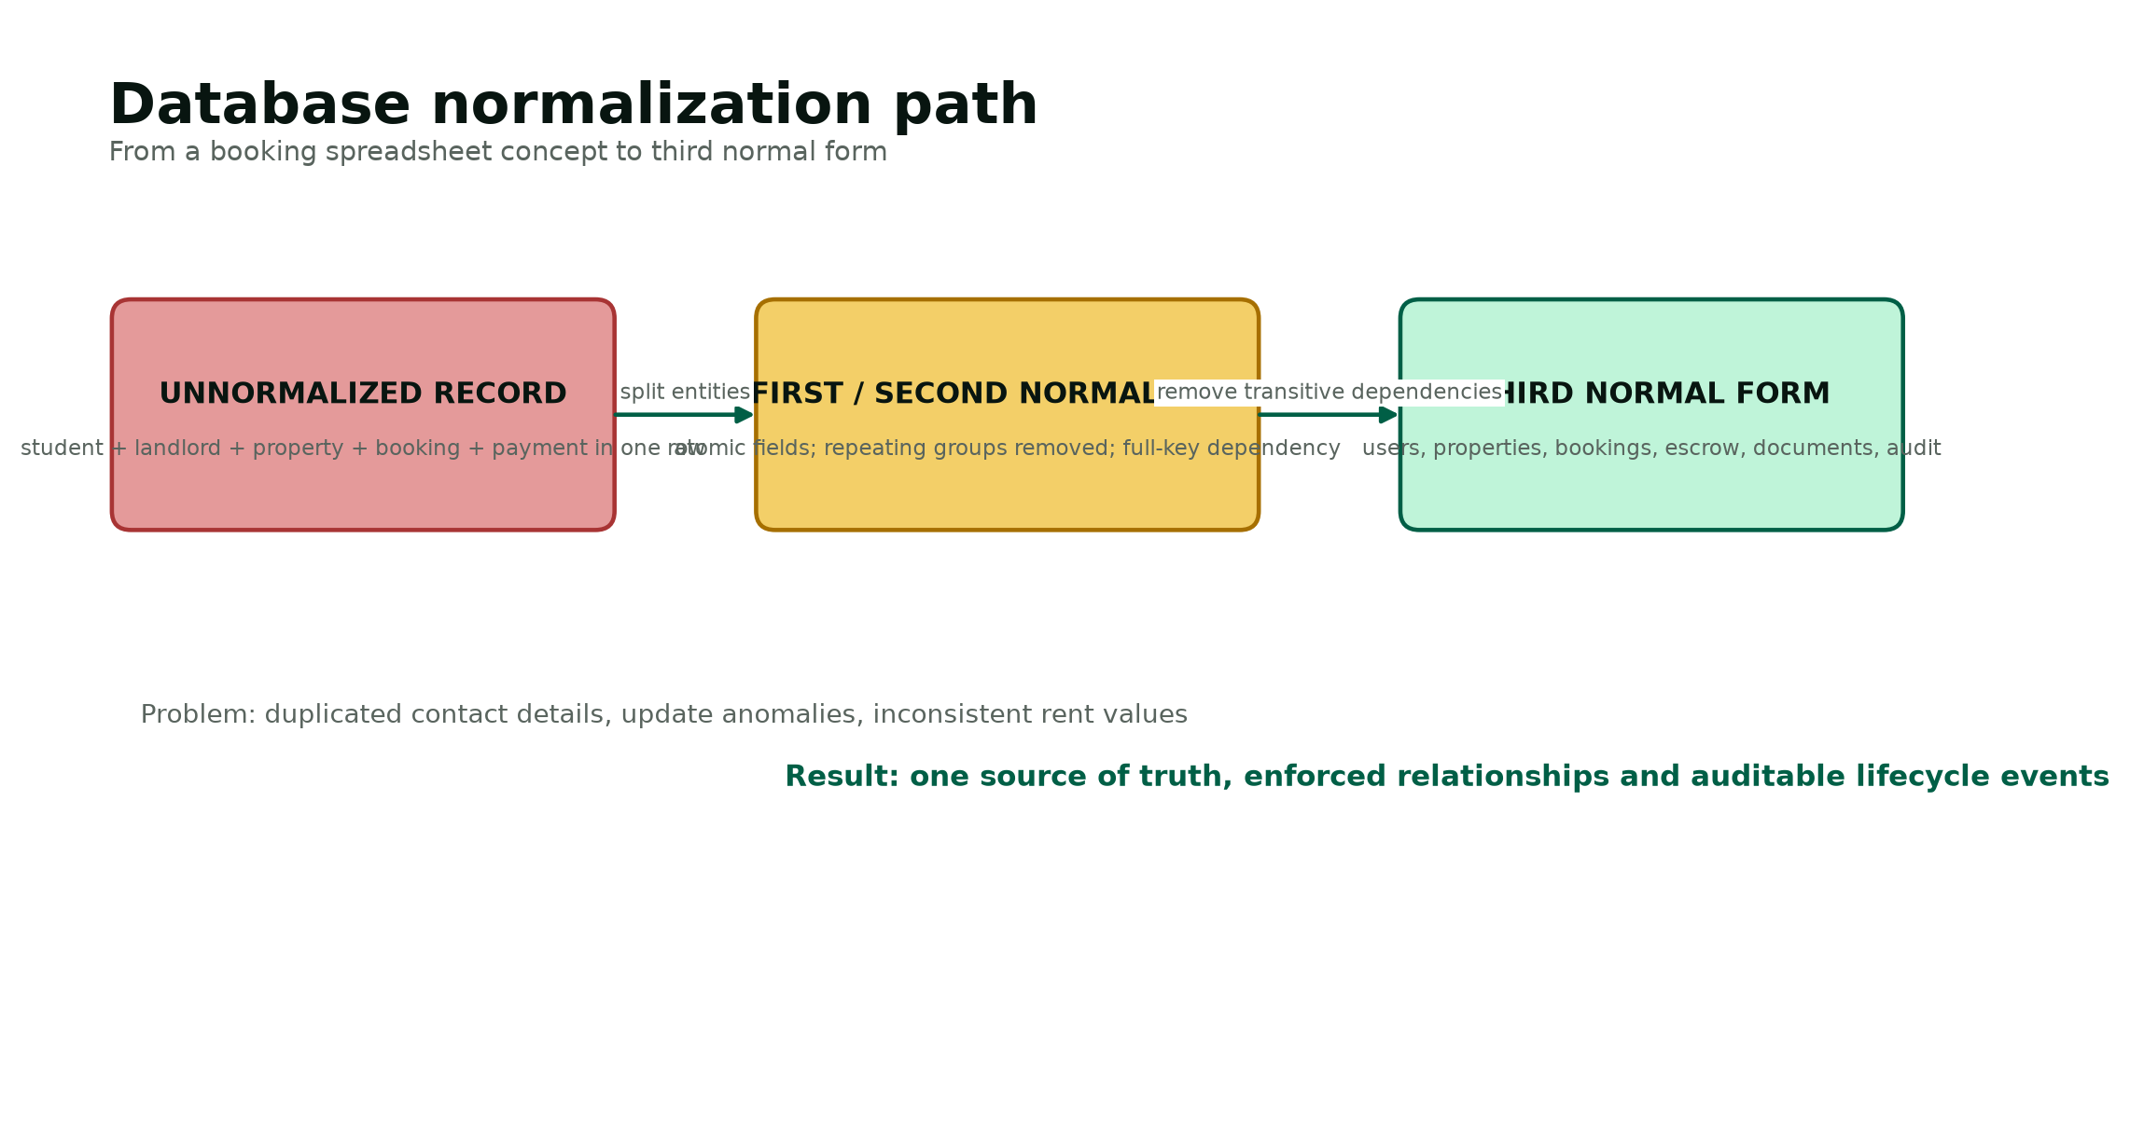
Figure 7. Normalization analysis that removes duplication and update anomalies.

Analysis of the Proposed System
The proposed system is a responsive web application with a public discovery layer and three protected role dashboards. Visitors browse published properties and safety guidance. A student account creates bookings and documents, a landlord account manages only its own property requests, and an administrator account controls verification. The application service layer validates every request, applies authorization, changes database state inside transactions where necessary and creates audit evidence. The MySQL layer enforces the relationships that remain valid even if an application page contains a defect.
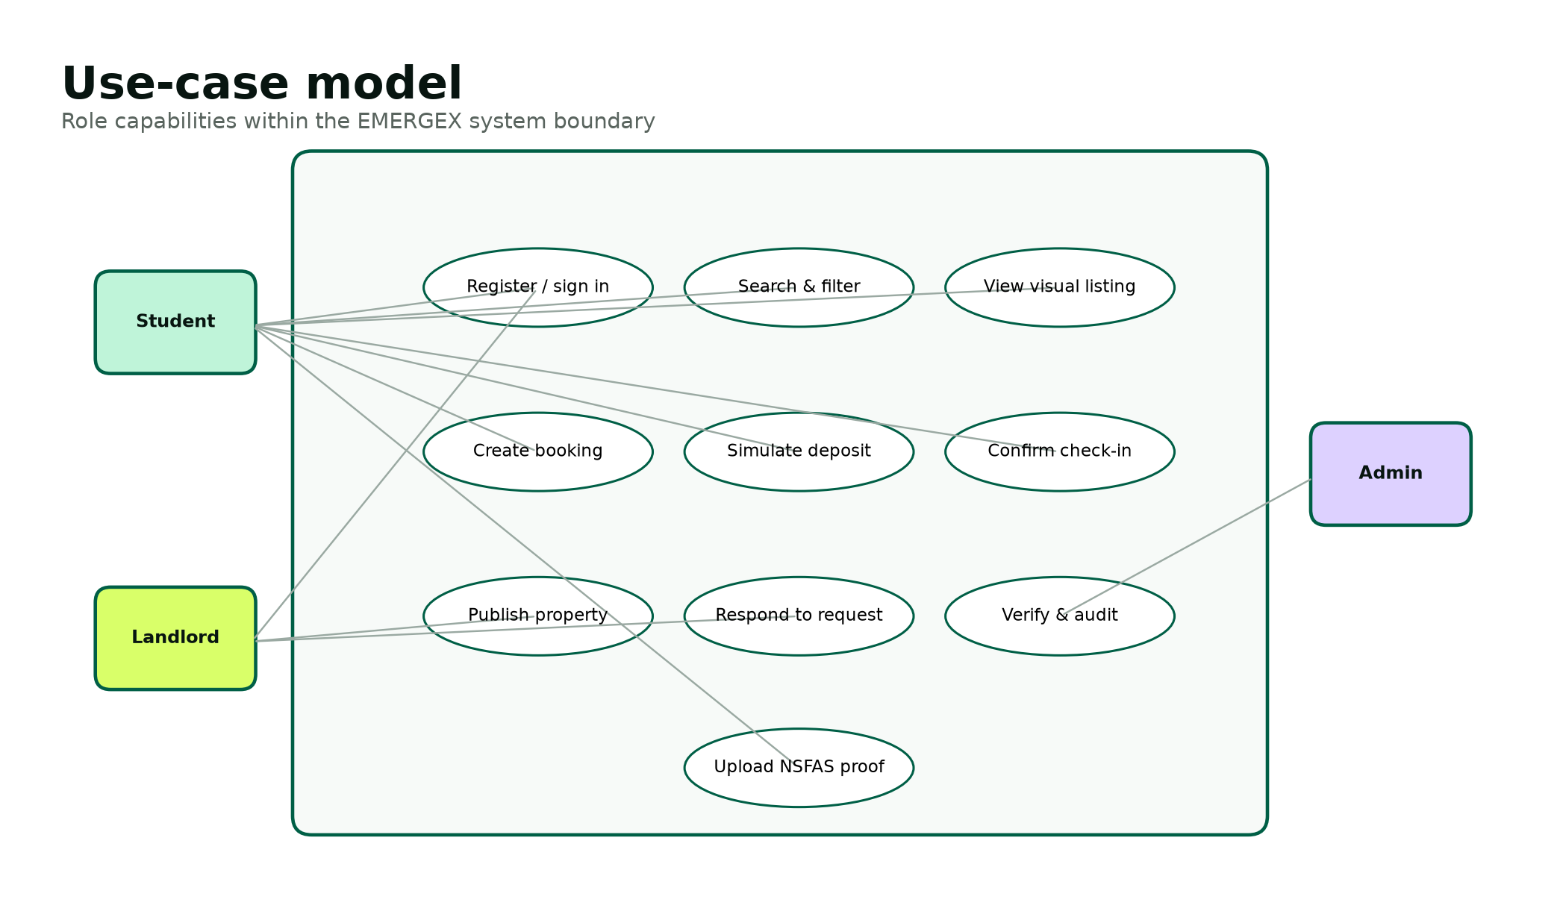
Figure 8. Role-based use-case model for the proposed system.

Functional Requirements
Table 20. Functional requirements specification
ID | Requirement | Priority
FR-01 | Register a student with name, email, phone, student number and compliant password. | Must
FR-02 | Register a landlord without granting verification automatically. | Must
FR-03 | Authenticate an active account and rotate its session identifier. | Must
FR-04 | End an authenticated session and expire the session cookie. | Must
FR-05 | Display only verified, published property listings to visitors. | Must
FR-06 | Search listings by title, city, suburb or nearby institution. | Must
FR-07 | Filter listings by maximum price, NSFAS status and Instant Book. | Must
FR-08 | Display rent, deposit, availability, address, amenities and trust badges. | Must
FR-09 | Display visual evidence categories for walkthrough, floor plan and 360 tour. | Should
FR-10 | Create a standard booking request for an authenticated student. | Must
FR-11 | Store a 12-hour response deadline for a standard request. | Must
FR-12 | Auto-approve eligible Instant Book requests. | Must
FR-13 | Prevent a non-student from creating a student booking. | Must
FR-14 | Allow a landlord to view requests for owned properties only. | Must
FR-15 | Allow a landlord to approve or reject a pending request. | Must
FR-16 | Prevent transitions from a non-pending request. | Must
FR-17 | Create one escrow simulator record with every booking. | Must
FR-18 | Allow a student to simulate deposit hold only after approval. | Must
FR-19 | Allow release only after held status and check-in confirmation. | Must
FR-20 | Display booking and deposit milestones on the student dashboard. | Must
FR-21 | Upload demo NSFAS evidence using an approved file type and size. | Should
FR-22 | Allow an administrator to approve or reject uploaded evidence. | Must
FR-23 | Allow an administrator to verify a landlord. | Must
FR-24 | Allow an administrator to verify and publish a property. | Must
FR-25 | Write audit events for critical state changes. | Must
FR-26 | Show administrator totals for users, properties, bookings and simulated held amount. | Should
FR-27 | Provide a local command-line database installer and seed data. | Must
FR-28 | Provide clear empty and database-not-installed states. | Should
FR-29 | Provide responsive navigation and form layouts. | Must
FR-30 | Disclose that no real funds are processed. | Must

Non-Functional Requirements
Table 21. Non-functional requirements specification
ID / category | Requirement
NFR-01 Security | All database values originating from a user shall be bound through prepared statements.
NFR-02 Security | Passwords shall be stored only as one-way password_hash outputs and verified with password_verify.
NFR-03 Security | All state-changing forms shall validate a session-bound CSRF token.
NFR-04 Security | The server shall enforce role and record ownership; hidden buttons are not authorization.
NFR-05 Privacy | Only data necessary for account, verification and booking shall be collected in the prototype.
NFR-06 Privacy | The academic prototype shall use demo documents and define deletion after assessment.
NFR-07 Performance | A seeded listing search should complete within two seconds on a local XAMPP device.
NFR-08 Availability | The local demonstration shall run without internet access after installation.
NFR-09 Usability | Critical actions and statuses shall use plain language and remain visible at mobile widths.
NFR-10 Accessibility | Pages shall use semantic headings, labels, keyboard-accessible controls and sufficient contrast.
NFR-11 Reliability | Booking plus escrow creation and hold/release updates shall be atomic database transactions.
NFR-12 Maintainability | Configuration, shared security functions, assets, database scripts and tests shall be separated.
NFR-13 Portability | The application shall run on PHP 8.1+ with PDO MySQL and Fileinfo in XAMPP.
NFR-14 Auditability | Critical events shall identify action, actor, time, entity and IP address when available.
NFR-15 Recoverability | The database shall be restorable from versioned schema/seed scripts and operational backups.

Data Modelling
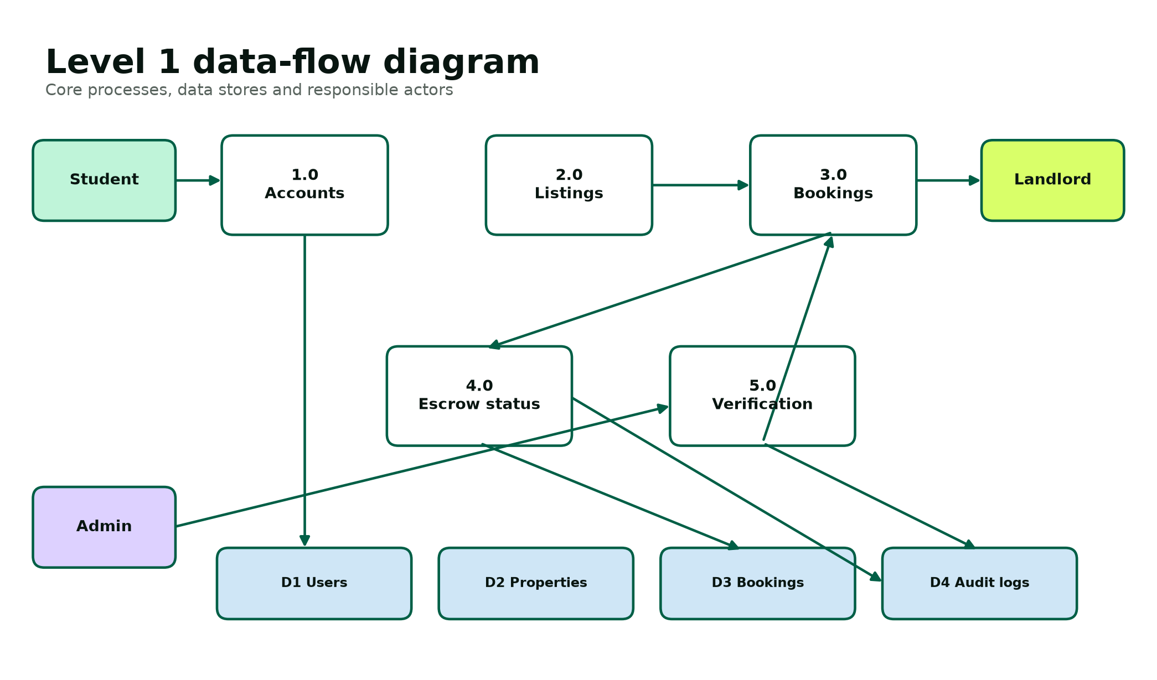
Figure 9. Level 1 data-flow model for the proposed system.
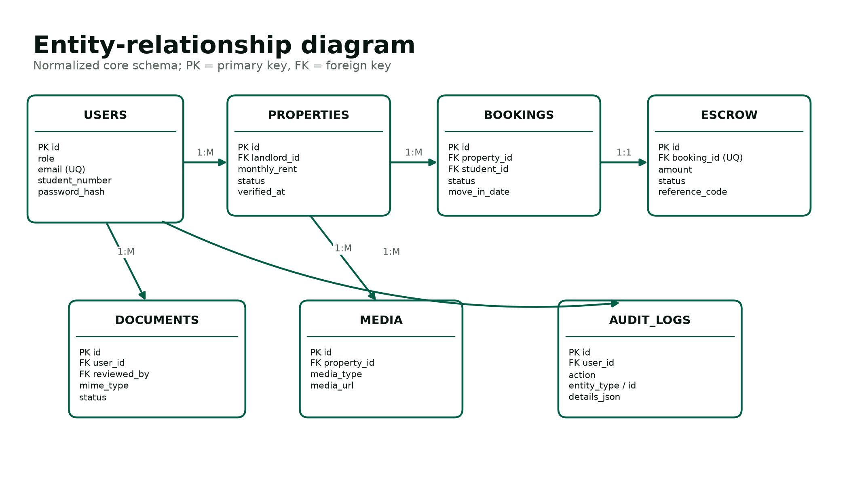
Figure 10. Entity-relationship model for the normalized database.
The data-flow model separates account, listing, booking, escrow and verification responsibilities. The ERD then allocates persistent state to seven tables. Users is the common identity source; role-specific behaviour is enforced in application logic. Properties reference the landlord owner. Bookings reference the selected property and student and capture price at the time of request. Escrow transactions record the simulated financial lifecycle. Documents preserve review metadata without exposing stored file names as public links. Audit logs remain intentionally generic so new critical actions can be recorded without changing the schema.

Requirements Validation and Traceability
Table 22. Requirements traceability sample
Requirement | Design element | Implementation location | Verification
FR-05 Verified listing search | Published + verified property rule | public/properties.php | ST-05 / ST-06
FR-11 Response deadline | Booking response_deadline | public/book.php | ST-14
FR-17 One escrow per booking | UNIQUE booking_id and DB transaction | schema.sql + book.php | DB-04 / ST-18
FR-18 Deposit hold guard | Booking state machine | public/dashboard.php | ST-19 / SEC-08
FR-21 Validated upload | Upload allow-list and protected folder | dashboard.php + .htaccess | SEC-11 to SEC-15
FR-23 Administrator verification | RBAC and audit control | public/admin.php | ST-29 / SEC-06
NFR-02 Password protection | Password API design | register.php + login.php | SEC-01 / SEC-02
NFR-11 Atomic updates | InnoDB + transactions | book.php + dashboard.php | DB-03 / ST-20

Validation uses three questions for every requirement: Is it necessary for a stakeholder or rubric item? Is it unambiguous enough to design and test? Can the delivered system demonstrate objective evidence? Requirements that fail a question are revised, deferred to future scope or marked as a production dependency rather than being described as implemented.

PHASE 4

System Design Phase
The design translates validated requirements into modular software, data, interface, network, security and test structures.

Description of the Proposed System
EMERGEX is designed as a server-rendered, three-tier web application. Public pages offer search, property comparison and safety guidance. Protected pages form three role workspaces. The design favours explicit pages and shared security helpers over a complex framework so that the academic team can trace every form action to a query, rule and test. The database remains the source of truth for identity, ownership, availability, booking state, simulated escrow and audit evidence.
Table 23. Module decomposition
Module | Responsibilities | Primary data
Bootstrap and security services | Configuration, PDO connection, session policy, headers, escaping, CSRF, authorization, audit and utilities | Configuration, users, audit_logs
Identity | Student/landlord registration, login, logout and account status | users
Discovery | Published property query, search filters, property details and visual evidence | properties, users
Booking | Standard/instant request, response deadline, landlord decision and student status | bookings, properties, users
Escrow simulator | Create transaction, hold, release and reference generation | escrow_transactions, bookings
Document review | Validated upload, administrator approval/rejection and retention status | user_documents, users
Administration | Verification queues, metrics and audit monitoring | users, properties, documents, bookings, audit_logs
Presentation assets | Responsive layout, accessible navigation, local illustrations and status treatments | CSS, JavaScript, SVG assets

Architectural Design
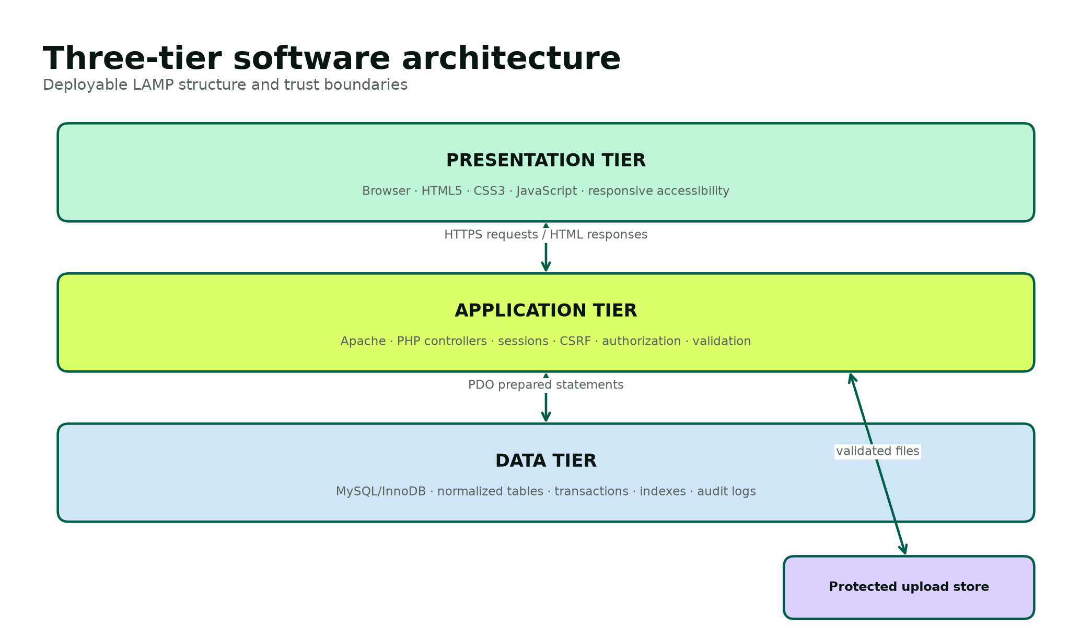
Figure 11. Three-tier LAMP software architecture.
The browser tier sends HTTPS requests and receives complete HTML responses. JavaScript is progressive enhancement for navigation and role-specific field visibility; business rules never depend on client-side code. The application tier validates requests, checks permissions and performs prepared SQL through PDO. The data tier uses InnoDB transactions and foreign keys. Uploaded demo files are stored under a protected directory with random file names, while metadata and review state remain in MySQL.
Table 24. Architecture decisions
Decision | Reason | Consequence
Server-rendered PHP pages | Minimizes build tooling and matches XAMPP teaching environment. | Simple deployment; page controllers must consistently call shared helpers.
Single bootstrap include | Centralizes security headers, sessions, database access and authorization. | One reviewed implementation controls all pages.
Native prepared statements | Separates SQL structure from user values [8]. | Reduced SQL injection exposure and clearer parameter tracing.
Database transactions for multi-record changes | Booking and escrow state must not diverge. | Failure rolls back both updates.
Local SVG illustrations | Demo remains visually complete without external image calls. | Images are representative, not evidence of real properties.
No real payment integration | Avoids unsafe or misleading financial functionality. | Escrow demonstrates state and audit only.
Minimal dependencies | Improves portability and auditability for the student team. | Some framework conveniences are implemented explicitly.

Hardware and Network Architecture
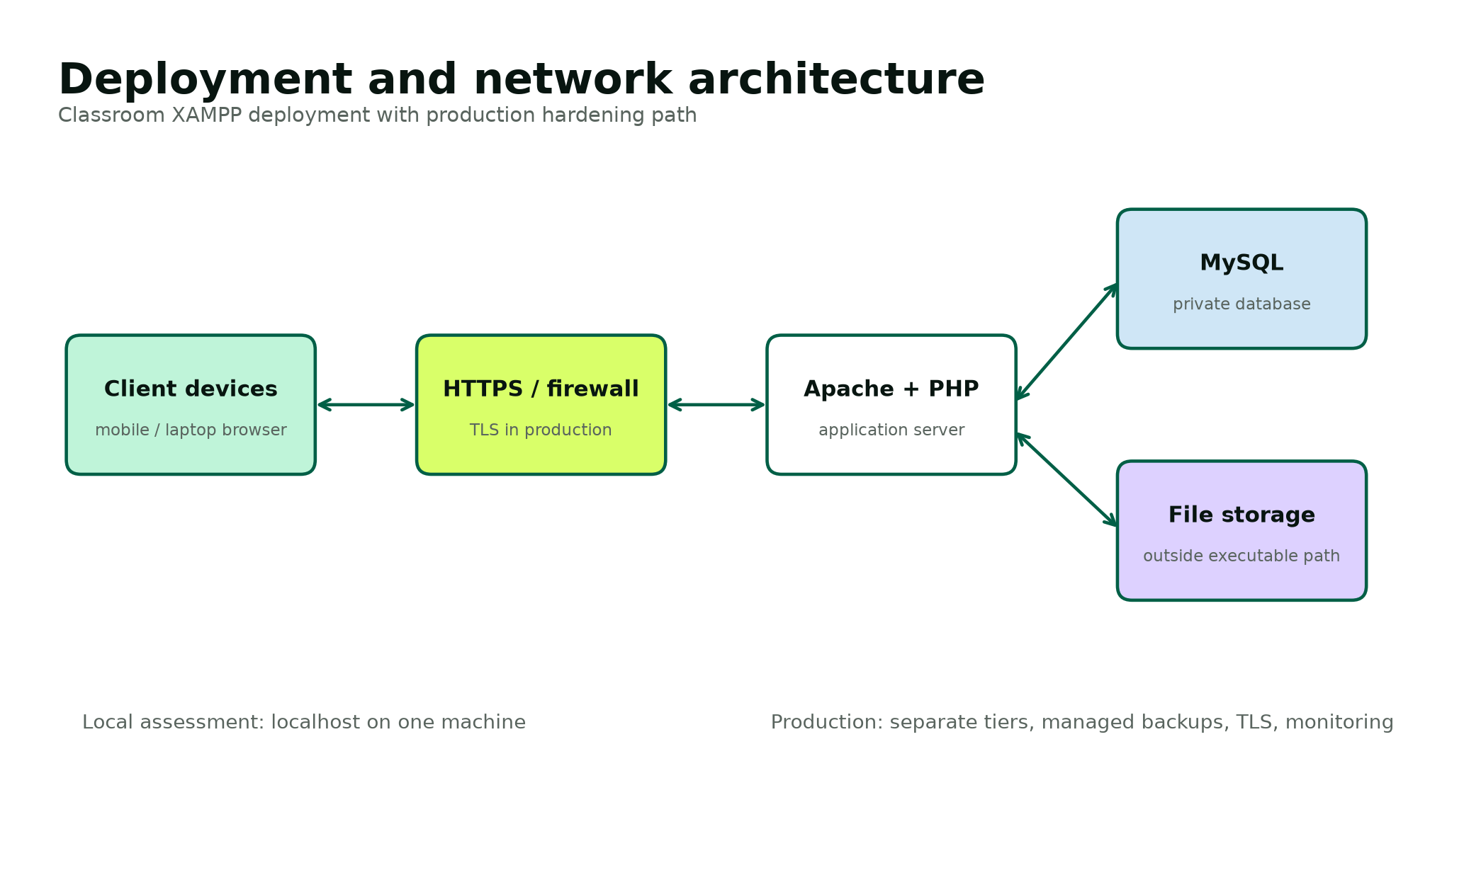
Figure 12. Deployment and network architecture.
Table 25. Deployment requirements
Environment | Minimum / proposed specification | Purpose
Developer workstation | Dual-core 64-bit processor, 8 GB RAM, 2 GB free disk, Windows 10/11 | Local coding, XAMPP, Word documentation and browser testing.
Assessment host | PHP 8.1+, Apache 2.4+, MySQL/MariaDB, Fileinfo and PDO MySQL | Runs the seeded offline demonstration.
Client | Current Chrome, Edge or Firefox; 360 px minimum viewport | Student, landlord and administrator interaction.
Production application tier | Hardened Linux host or managed container, TLS, WAF, monitoring and least-privilege service account | Future secure public service.
Production database tier | Private managed MySQL, encryption, point-in-time backups and restricted network access | Future durable data and recovery.
Backup storage | Encrypted, access-controlled and geographically separate | Future recovery evidence and retention enforcement.

Class and Behaviour Design
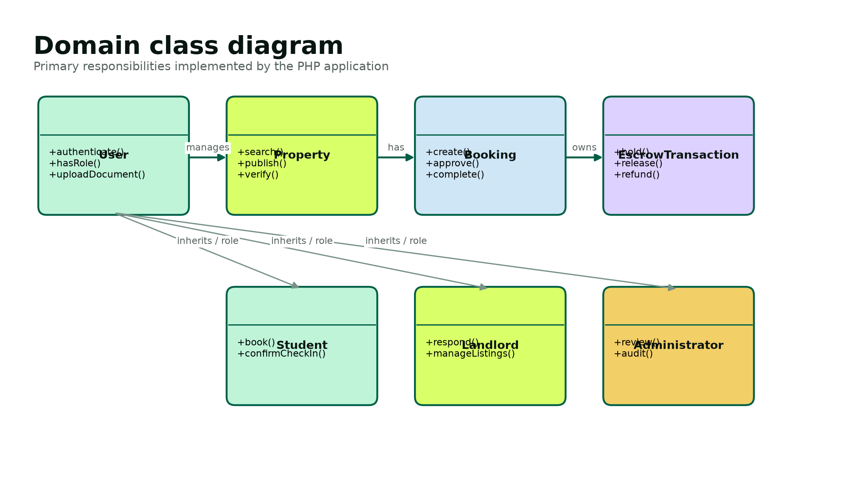
Figure 13. Domain classes and their responsibilities.
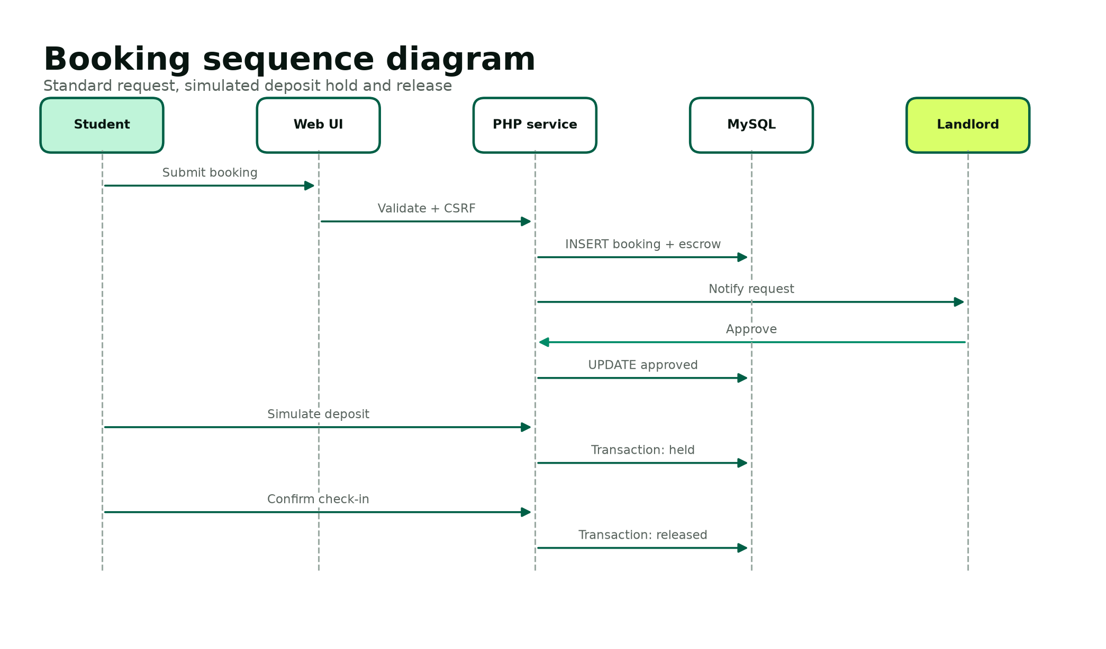
Figure 14. Booking request, approval and simulated escrow sequence.
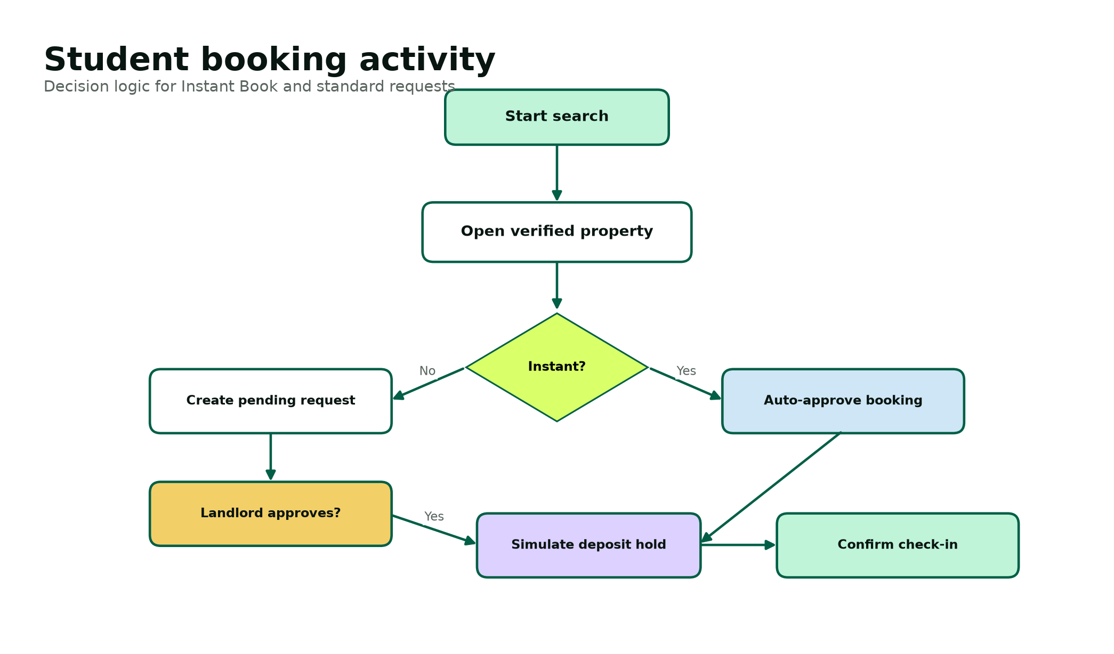
Figure 15. Student booking activity with Instant Book decision.
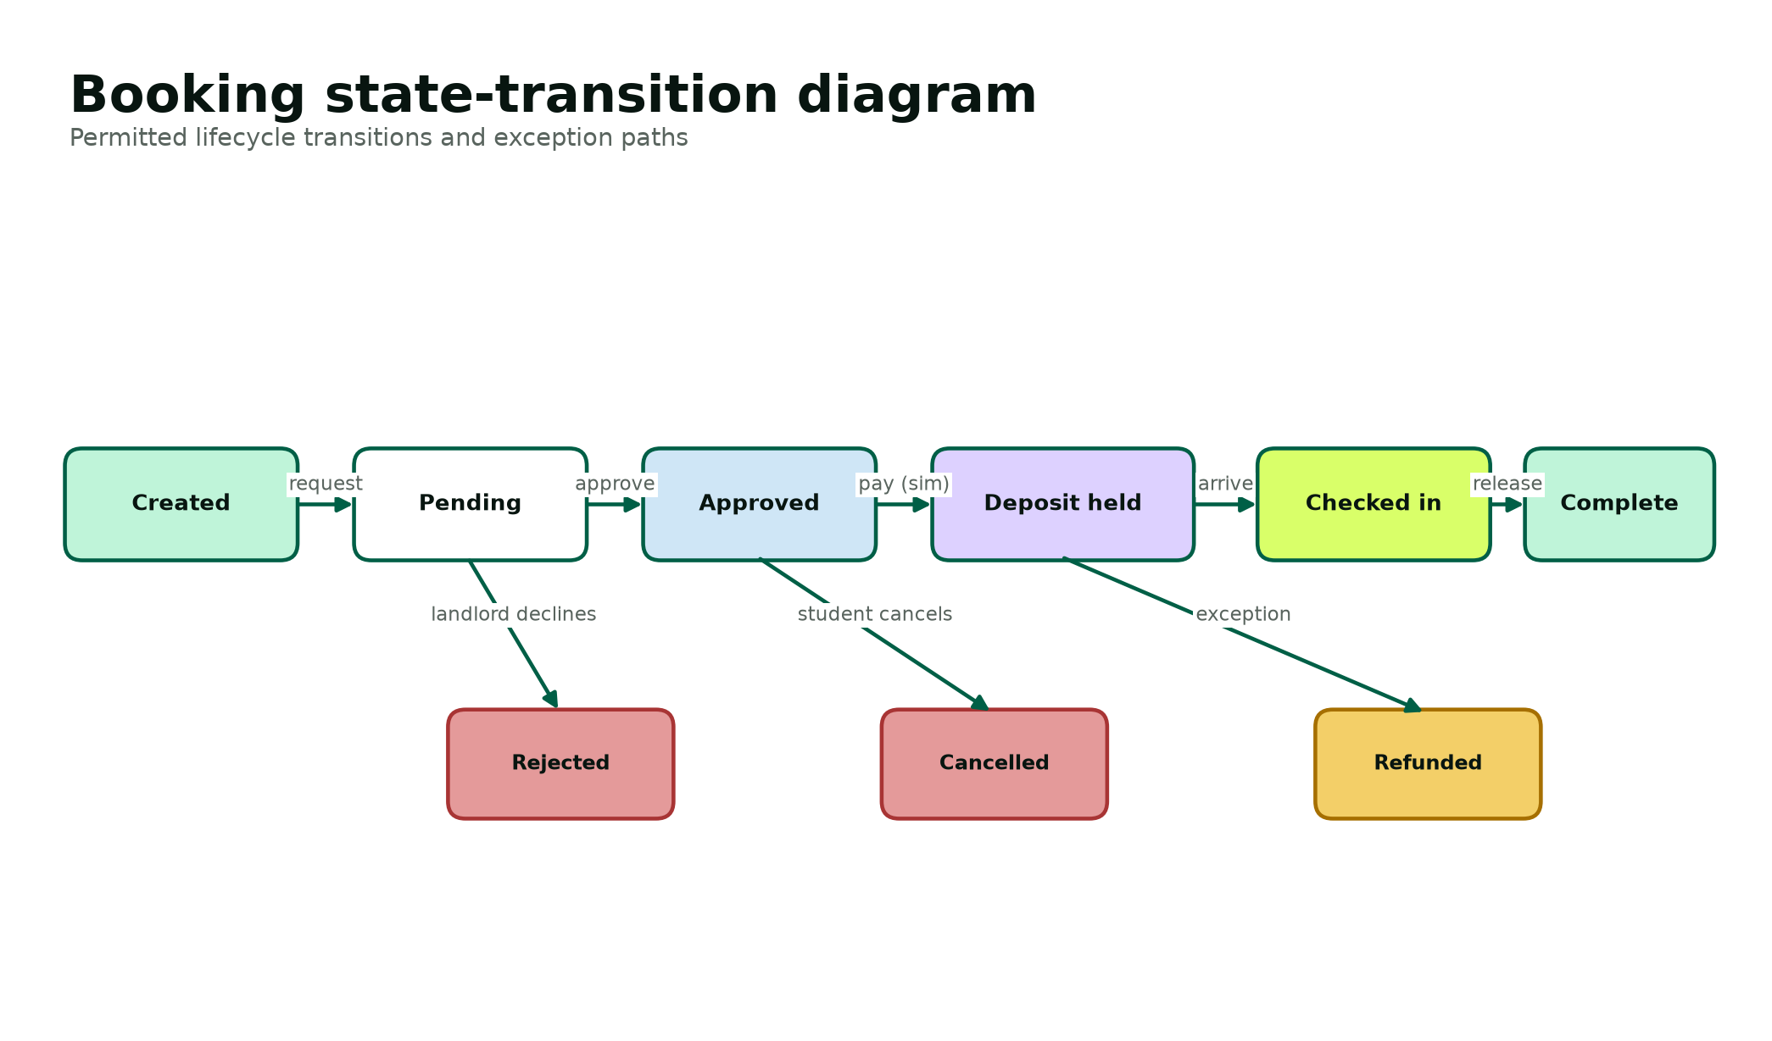
Figure 16. Permitted booking state transitions.
The state model is the design authority for booking actions. A standard request begins pending, while an Instant Book begins approved. Only pending requests can be approved or rejected. Only approved bookings can simulate a deposit hold. Only a held deposit can proceed to check-in and release. Cancellation or refund states are defined for production evolution, but the current UI implements the main successful path and landlord rejection. Every implemented transition is checked on the server and produces an audit event.

Physical and Database Design
The physical design uses seven InnoDB tables. Surrogate unsigned integer keys keep joins compact. Natural identifiers such as email, student number, escrow booking link and reference code receive unique constraints where appropriate. Foreign-key indexes support ownership and lifecycle queries. Search indexes combine property status, city and rent, while booking indexes combine actor and status. JSON is limited to amenities and generic audit details; core relationships and states remain typed relational columns.
Table 26. Database table dictionary
Table | Purpose | Primary relationships | Retention / sensitivity
users | Authentication identity and role | Parent of properties, bookings, documents and audit | Personal; retain only for active service and legal need.
properties | Accommodation listing, price, evidence flags and publication | Belongs to landlord; parent of media and bookings | Commercial/property data; review periodically.
property_media | Typed visual references and captions | Belongs to property | Remove with property.
bookings | Historical request, move-in, captured price and state | Belongs to property and student; parent of escrow | Transactional; retain for support/legal policy.
escrow_transactions | Simulated amount and lifecycle milestones | Exactly one per booking | Financial-like demo data; no real transaction details.
user_documents | Validated upload metadata and review outcome | Belongs to user; optionally reviewed by admin | Highly sensitive; demo only and delete after assessment.
audit_logs | Actor/action/entity/time evidence | Optional user reference | Security evidence; append-oriented and restricted.

Table 27. Selected field-level data dictionary
Entity.field | Type / size | Null? | Rule / meaning
users.id | BIGINT UNSIGNED | No | Primary key.
users.role | ENUM | No | student, landlord or admin.
users.email | VARCHAR(190) | No | Unique normalized login name.
users.student_number | VARCHAR(30) | Yes | Required for student role; unique when present.
users.password_hash | VARCHAR(255) | No | Self-contained password_hash output [7].
users.verified_at | DATETIME | Yes | Identity verification evidence time.
properties.landlord_id | BIGINT UNSIGNED | No | FK to landlord owner.
properties.monthly_rent | DECIMAL(10,2) | No | Positive current advertised rent.
properties.deposit_amount | DECIMAL(10,2) | No | Non-negative current deposit.
properties.instant_book | TINYINT(1) | No | Auto-approval eligibility.
properties.nsfas_accredited | TINYINT(1) | No | Reviewed accreditation flag.
properties.amenities_json | JSON | No | Display amenities array.
bookings.student_id | BIGINT UNSIGNED | No | FK to requesting student.
bookings.move_in_date | DATE | No | Requested date, today or later at entry.
bookings.monthly_rent | DECIMAL(10,2) | No | Historical rent captured at creation.
bookings.status | ENUM | No | Controlled lifecycle state.
bookings.response_deadline | DATETIME | Yes | Standard request creation + 12 hours.
escrow_transactions.booking_id | BIGINT UNSIGNED | No | Unique FK enforcing one-to-one.
escrow_transactions.status | ENUM | No | not_paid, held, released or refunded.
escrow_transactions.reference_code | VARCHAR(40) | Yes | Random simulator reference after hold.
user_documents.stored_name | VARCHAR(255) | No | Unique random name, not user supplied.
user_documents.mime_type | VARCHAR(100) | No | Server-inspected type.
audit_logs.action | VARCHAR(100) | No | Stable machine-readable event name.
audit_logs.details_json | JSON | Yes | Non-secret contextual details.

Normalization
First normal form is achieved by atomic user, property and booking columns; repeating property media records are stored separately. Second normal form is satisfied because non-key attributes depend on their complete table key. Third normal form removes landlord details from properties and student details from bookings: those facts depend on user identity and are joined through foreign keys. Escrow status is not stored as a property or user attribute because it depends on one booking. Historical rent and deposit are intentionally copied into a booking; this is a transaction snapshot, not accidental denormalization.
Table 28. Integrity and constraint design
Control | Database implementation | Application implementation
Entity integrity | Auto-increment primary key on every table. | IDs are parsed as integers and records must exist.
Referential integrity | Foreign keys between owners, properties, bookings, escrow, documents and audit users. | Ownership joins are included in protected actions.
Domain integrity | ENUM states, decimal types and CHECK constraints. | Allow-lists and state guards reject invalid values.
Uniqueness | Email, student number, escrow booking and stored filename constraints. | Duplicate registration returns a safe message.
Atomicity | InnoDB transactions. | Booking+escrow and hold/release updates commit or roll back together.
Confidentiality | Database remains outside public web assets. | Protected pages, escaped output and limited upload access.

Program Design and Pseudocode
The following pseudocode describes the highest-risk program paths. The delivered PHP uses the same validation, authorization, state and transaction order.
CREATE BOOKING
Require authenticated student
Validate CSRF token and property_id
Load verified, published property
Validate move-in date and message length
Begin database transaction
status := approved if Instant Book else pending
deadline := null if Instant Book else now + 12 hours
insert booking with captured rent and deposit
insert one escrow transaction with status not_paid
Commit transaction
Write audit event and redirect to student dashboard
SIMULATE DEPOSIT HOLD
Require authenticated student
Load booking + escrow WHERE booking.student_id = current_user.id
If booking.status != approved OR escrow.status != not_paid: reject
Begin transaction
update escrow to held, paid_at=now, random reference
update booking to deposit_held
Commit
Write audit event and show explicit no-real-funds message
CONFIRM CHECK-IN AND RELEASE
Require authenticated student and verify CSRF
Load owned booking and escrow
If booking.status != deposit_held OR escrow.status != held: reject
Begin transaction
update escrow to released and released_at=now
update booking to completed and checked_in_at=now
Commit
Write audit event and display completed reference
VALIDATE DOCUMENT UPLOAD
Require authenticated student and verify CSRF
Reject upload error or size > 5 MB
Inspect temporary file MIME using Fileinfo
Allow only PDF, JPEG or PNG
Generate random 40-character stored name and approved extension
Move file into protected uploads directory
Insert metadata with pending review state
Write audit event; never execute or expose original filename as a path

Interface Design
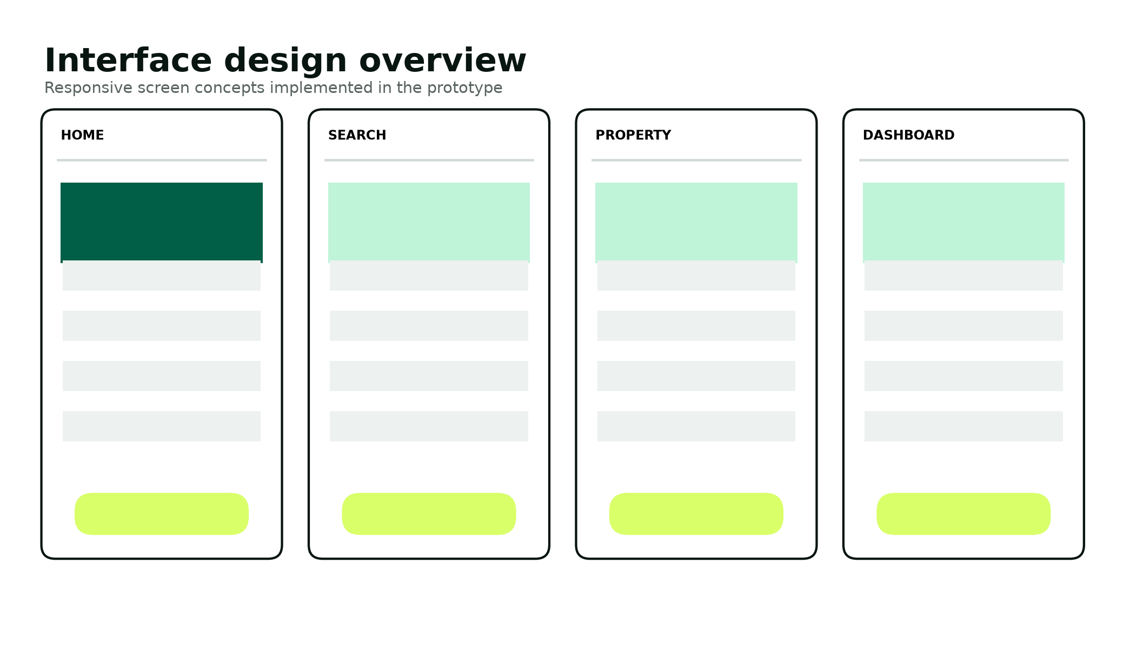
Figure 17. Interface design family implemented across the prototype.
Table 29. Screen design specification
Screen | Primary user task | Key controls / output | Validation and feedback
Home | Understand value and begin search | Hero search, trust pillars, featured listings and landlord call to action | Database setup state remains graceful.
Search | Narrow accommodation choices | Location, price, NSFAS and Instant Book filters | Empty state suggests widening filters.
Property | Make an informed decision | Visual proof, badges, rent, deposit, availability, amenities and booking action | Only published properties resolve.
Registration / login | Create or access role account | Labeled fields, role choice and password help | Server validation; generic login errors and throttling.
Student dashboard | Track and advance owned bookings | Status label, move-in facts, deposit/check-in actions and document upload | Actions appear only for valid states; server rechecks.
Landlord dashboard | Respond to owned property requests | Pending queue, message, approve/decline and metrics | Ownership join and pending-state guard.
Administrator dashboard | Review trust evidence | Verification queues, document decisions, totals and audit feed | Admin role gate and audited decisions.

Input Validation Design
Table 30. Input validation matrix
Input | Client constraint | Server constraint | Failure response
Email | email input type | FILTER_VALIDATE_EMAIL; normalized lowercase; unique | Specific registration duplicate, generic login error
Password | Help text and required field | At least 10 chars with upper, lower and number | Return policy message without echoing value
Phone | Required text | 9-20 approved phone characters | Return field-level message
Student number | Shown/required for student | Non-empty for student; unique when present | Reject registration
Property ID | Hidden/query integer | FILTER_VALIDATE_INT; load approved record | 404 or invalid action
Move-in date | date input with minimum today | Strict date parse and not before today | Return booking error
Booking message | maxlength 1000 | Trim and enforce <=1000 characters | Return booking error
Filter price | number min/step | Validated float and bound parameter | Ignore invalid optional filter
NSFAS upload | accept attribute | Upload error, <=5 MB, Fileinfo MIME allow-list | Safe error and no metadata insert
Action/state | Hidden action token | Allow-list, role, ownership and current state | 400/403 and no state change

Output and Report Design
All dynamic output is escaped before insertion into HTML. Dashboards report human-readable state labels while preserving machine-readable states in the database. The administrator dashboard provides operational totals and recent audit activity. The final report includes sample booking, property and verification outputs; production evolution can export filtered CSV or PDF reports without changing the transactional core.

Security and Backup Design
Table 31. Security control design
Threat / concern | Preventive control | Detective / recovery control
SQL injection | PDO prepared statements and allow-listed query structure [8]. | Database error logging without showing SQL to users.
Password disclosure | password_hash/password_verify; never store plaintext [7]. | Force reset and investigate account events in production.
Session theft/fixation | HttpOnly, SameSite, Secure-on-HTTPS cookies; ID rotation; OWASP-aligned session practice [9]. | Logout destruction, timeout policy and event monitoring.
CSRF | Random session token on state-changing forms; hash_equals verification. | Reject with 419 response and log repeated production failures.
Broken access control | Server role and ownership queries on every protected action. | Audit admin and escrow state changes.
XSS | Contextual htmlspecialchars output and restrictive Content Security Policy. | Security review and browser console monitoring.
Malicious upload | Size/MIME allow-list, random name, blocked executable extensions. | Quarantine/reject, review metadata and delete demo files.
Personal data over-collection | Purpose limitation, minimal prototype fields and demo-only documents [6]. | Retention review, deletion process and access audit.
Data loss | Versioned schema, regular encrypted backup and restore testing. | Recovery point/time objectives and incident runbook.
Fraudulent verification | Separate admin decision and visible timestamp. | Suspension, evidence preservation and audit review.

Table 32. Backup and recovery plan
Asset | Frequency | Method | Retention / restore test
MySQL production database | Daily full + frequent incremental/binlog | Encrypted automated backup to separate account/region | 30 daily, 12 monthly; quarterly restore test
Uploaded evidence | Daily encrypted object replication | Versioned private object storage | Policy-driven; delete when purpose ends
Application code | Every accepted change | Version-control remote plus release archive | Retain tagged academic and production releases
Configuration secrets | On change | Managed secret store; never in repository | Versioned access policy; rotation drill
Academic local demo | Before presentation and submission | Zip package plus SQL schema/seed and offline deck | Keep assessment copy; reset demo after use

Design Test Cases
Test cases are designed before implementation completion so acceptance is based on requirements rather than on whatever the code happens to do. Each case identifies preconditions, input/action, expected result and evidence. The complete execution register appears in Phase 5.
Table 33. Representative design-stage test cases
ID | Requirement | Scenario | Expected result
TC-D01 | FR-03 | Sign in with correct active demo account. | Session ID rotates and correct role dashboard opens.
TC-D02 | FR-05 | Search while an unverified draft property exists. | Draft property never appears.
TC-D03 | FR-11 | Create standard request at a known time. | Pending booking stores deadline exactly 12 hours later.
TC-D04 | FR-12 | Book an eligible Instant Book listing. | Booking begins approved and escrow begins not_paid.
TC-D05 | FR-14 | Landlord changes booking ID to another owner. | No record is returned and action fails.
TC-D06 | FR-18 | Try deposit hold before approval. | State remains unchanged.
TC-D07 | FR-19 | Confirm check-in after valid hold. | Booking completes and escrow releases in one transaction.
TC-D08 | FR-21 | Upload a renamed executable file. | MIME/type validation rejects the file.
TC-D09 | FR-23 | Student posts administrator verification action. | Role gate returns forbidden; no record changes.
TC-D10 | NFR-03 | Submit form with missing/incorrect CSRF token. | 419 response and no state change.

PHASE 5

Implementation Phase
Implementation realizes the approved design as a complete local LAMP prototype, database package, seeded demonstration and verification assets.

Implementation Overview
The delivered application is located in the application folder and is organized into configuration, shared application services, public web pages, database scripts, protected uploads, assets and tests. The implementation follows a vertical-slice approach: authentication, listing search, booking creation, landlord response, escrow simulation, document review, audit monitoring and operational reporting each include interface, validation, authorization and persistence logic. The README provides installation, demonstration accounts, backup and restore commands, and a scripted assessment journey.
Table 34. Implemented feature inventory
Area | Delivered capability | Evidence location
Public discovery | Landing page, safety explanation, search/filter, property details and responsive navigation | public/index.php, properties.php, property.php, how-it-works.php
Identity | Student/landlord registration, role routing, login throttle, session rotation and logout | public/register.php, login.php, logout.php
Student workflow | Booking creation, Instant Book, 12-hour request, deposit hold, check-in and upload | book.php, dashboard.php
Landlord workflow | Owned property summary and pending booking approval/rejection | landlord.php
Administration | Landlord/property verification, document decisions, metrics and recent audit | admin.php
Operational reporting | Administrator-only booking, property and audit reports; print/PDF control and CSV exports | reports.php and assets/css/reports.css
Security services | Prepared PDO, CSRF, escaping, headers, RBAC, upload validation and audit helper | app/includes/bootstrap.php
Database | Seven normalized tables, constraints, indexes, seed and transactional installer | database/schema.sql, seed.sql, install.php
Recovery | Timestamped database backup and guarded restore scripts with demonstrated restore evidence | runtime-tools/BACKUP_EMERGEX.ps1 and RESTORE_EMERGEX.ps1
Presentation | Deep Emerald responsive style, local SVG property assets and progressive JavaScript | public/assets
Verification | Static security checks, acceptance evidence and information-session controls | tests/security_checks.php and test-evidence

Coding Standards and Efficiency
Table 35. Coding standard
Standard | Application
Strict typing | Every PHP file begins with declare(strict_types=1).
Naming | Functions and variables use descriptive snake_case or camelCase consistently; SQL states use stable lowercase identifiers.
Separation of concerns | Configuration, shared services, layout, assets, database installation and workflow pages are separated.
Input handling | External values are trimmed, type-validated and allow-listed before use.
Output handling | Dynamic HTML is escaped through the shared e() helper.
Database access | Prepared statements bind values; multi-record state changes use transactions.
Authorization | Protected actions load records through role and ownership predicates.
Error handling | Expected validation creates safe user messages; detailed internals are not exposed.
Comments | Comments explain security boundaries and non-obvious implementation choices, not restate syntax.
Efficiency | Search uses indexed fields; dashboards use bounded queries; static assets are local and small.

Representative Code Segments
The complete source is delivered separately. Short extracts below illustrate the security and transaction patterns without turning the report into a code listing.
// Native prepared statement with bound user input
$stmt = db()->prepare('SELECT id, password_hash, status FROM users WHERE email = ? LIMIT 1');
$stmt->execute([$email]);
$account = $stmt->fetch();
// Constant-time CSRF verification
$provided = $_POST['csrf_token'] ?? '';
if (!is_string($provided) || !hash_equals(csrf_token(), $provided)) {
http_response_code(419);
exit('The form expired.');
}
// Transaction protects escrow and booking state together
$pdo->beginTransaction();
$pdo->prepare("UPDATE escrow_transactions SET status='held' ...")->execute([...]);
$pdo->prepare("UPDATE bookings SET status='deposit_held' ...")->execute([$bookingId]);
$pdo->commit();

Error Handling and Validation
Validation failures are treated as normal user-facing outcomes; they return a precise next step without revealing server details. Authorization failures return an appropriate 403, missing records return 404, invalid state transitions return 400 and CSRF failure returns 419. Database work that changes two linked records is wrapped in a transaction and rolls back on an exception. Registration catches a duplicate-key condition and reports that the email is already used. Login always uses a generic credential error to reduce account enumeration.
Table 36. Implemented exception paths
Path | Trigger | System response
Database not yet installed | Home or listing page cannot connect | Landing page remains usable; listing page displays setup-required empty state.
Duplicate registration | Unique email constraint violation | No account created; safe duplicate message.
Login abuse | Five failed attempts in ten minutes in the session | HTTP 429 and wait message.
Expired form | Missing or mismatched CSRF token | HTTP 419; no state change.
Unauthorized role | User opens a different role dashboard | HTTP 403.
Ownership mismatch | Landlord or student changes record ID | Protected query returns no record; action stops.
Invalid booking state | Action is not permitted from current state | HTTP 400 or no action; existing state remains.
Upload failure | Transport, size or MIME check fails | No file metadata is inserted; safe error displayed.
Transactional database error | One linked state update fails | Rollback preserves previous consistent state.

Installation
- Install or open XAMPP with Apache, PHP 8.1 or later, MySQL/MariaDB, PDO MySQL and Fileinfo.
- Copy the delivered application folder to C:\xampp\htdocs\emergex.
- Start Apache and MySQL from the XAMPP Control Panel.
- Review app/config/config.php; the included values use localhost, root, blank password and /emergex/public.
- Open Command Prompt in C:\xampp\htdocs\emergex and run C:\xampp\php\php.exe database\install.php.
- Browse to http://localhost/emergex/public/.
- Sign in with the seeded student, landlord and administrator accounts documented in README.md.
- Run C:\xampp\php\php.exe tests\security_checks.php and record the output in the execution register.
- Open the administrator Reports page, print or save the operational report as PDF, and export each CSV evidence file.
- Run runtime-tools\BACKUP_EMERGEX.ps1, verify the timestamped SQL file, and demonstrate RESTORE_EMERGEX.ps1 -SqlFile <path> -ConfirmRestore only against the assessment database.
Table 37. Seeded demonstration accounts
Role | Email | Password | First demonstration action
Student | student@emergex.test | Student@55 | Open an Instant Book property and complete the simulated lifecycle.
Landlord | landlord@emergex.test | Landlord@55 | Approve or reject the seeded standard request.
Administrator | admin@emergex.test | Admin@55Secure | Review verification state and audit events.

Reset warning
Running the installer again drops and recreates the EMERGEX tables. Back up any demo data that must be retained before resetting.

Operational Demonstration Script
Table 38. Assessment demonstration sequence
Step | Actor | Action | Expected evidence
1 | Team | Start XAMPP and show the seven-table database. | Local application and MariaDB are available without internet.
2 | Visitor | Search by city and apply price/NSFAS/Instant filters. | Only verified published records appear; empty states are clear.
3 | Student | Sign in, book an Instant property, hold the deposit and complete check-in. | Booking and escrow states update atomically with a SIM reference.
4 | Landlord | Review and approve an owned standard request. | Only owned requests are visible; status and audit update.
5 | Administrator | Inspect verification queues and decide a demo document. | Verification state, reviewer and audit evidence update.
6 | Administrator | Open Reports, print/save the report and export CSV evidence. | Booking, property and audit outputs are generated from current records.
7 | Team | Show security helpers and the 32/32 evidence register. | Prepared statements, password, CSRF, access and upload controls are traceable.
8 | Team | Retrieve the timestamped SQL backup and explain the tested restore. | Backup path, guarded command and restored seven-table result are visible.

Presentation control - 20 August 2026 information session
Use the separate 15-minute live demonstration runbook. All six members must attend, explain their own contribution and understand neighbouring code, database, security and recovery controls. Keep the supporting deck, SQL backup and a second offline project copy ready.

VERIFICATION

Testing and Evaluation
Testing combines structural control checks with repeatable unit, integration, system, security, usability and acceptance scenarios.

Testing Strategy
The strategy is risk-based. Authentication, access control, booking state and upload handling receive the most negative testing because failure could expose personal data or corrupt a transaction. Lower-risk presentation behaviour is checked across common viewport sizes and browsers. Static checks verify that required control patterns are present. Database tests verify constraints and atomic updates. End-to-end cases use the seeded accounts so evidence can be reproduced after every installer reset.
Table 39. Testing levels
Level | Purpose | Examples | Evidence
Static / review | Detect missing security and structure before runtime. | Prepared statements, password APIs, CSRF, upload blocking, InnoDB and foreign keys. | security_checks.php output and code review checklist.
Unit | Verify pure or narrowly scoped rules. | Password policy, status labels, money display and date validation. | Function assertions or controlled page inputs.
Database | Verify schema and transaction rules. | Unique email, FK rejection, one escrow per booking and rollback. | SQL results and before/after row counts.
Integration | Verify page, service and database interactions. | Registration, booking+escrow, landlord decision and document review. | Database snapshots and audit events.
System | Verify complete role journeys. | Search to completion, request approval and admin verification. | Screen captures and execution log.
Security | Challenge trust boundaries and invalid input. | CSRF, ID tampering, role bypass, MIME spoof and XSS payload. | HTTP response, unchanged data and audit evidence.
Usability / accessibility | Confirm understandability and operability. | Keyboard flow, labels, contrast, mobile layout and status comprehension. | Reviewer notes and corrected defects.
Acceptance | Confirm rubric and stakeholder outcomes. | All five phases, runnable product and presentation story. | Traceability matrix and supervisor sign-off.

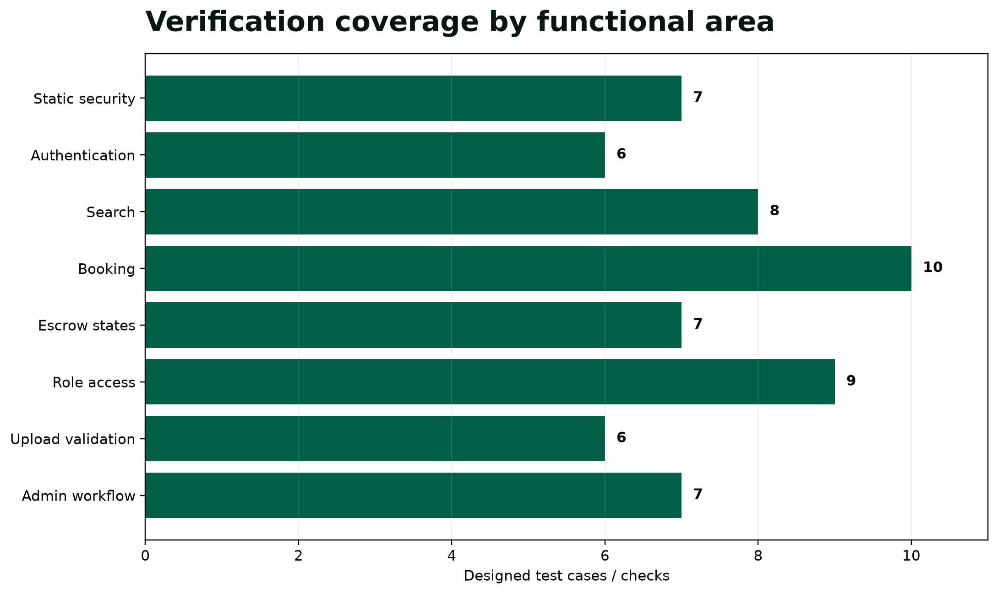
Figure 18. Designed verification coverage across functional areas.

Environment and Evidence Status
Verified runtime result - updated 21 August 2026
The official XAMPP 8.2.12 portable distribution supplied PHP 8.2.12 and MariaDB 10.4.32 for the execution session. All 32 documented acceptance cases passed, together with all seven structural security checks and syntax validation for all 21 PHP files. The administrator report centre returned current data, exposed print/PDF and three CSV exports, and remained responsive at 360 and 1440 px. A timestamped SQL backup was created and restored successfully to seven tables. Detailed evidence is delivered in the test-evidence folder.

The first runtime pass discovered that the NSFAS upload action was incorrectly subjected to booking lookup. The dashboard control flow was corrected so upload actions are independent while booking lookup remains mandatory for escrow actions. Upload, negative-file and full regression tests were rerun; the final verified result is 32/32 PASS. This evidence supports academic acceptance of the prototype, not a claim of production certification or regulated payment readiness.
Table 40. Runtime execution summary
Evidence | Observed result | Status
Environment | XAMPP 8.2.12; PHP 8.2.12; MariaDB 10.4.32 | PASS
Install and seeded database | 7 tables and 3 demonstration accounts created from a clean reset | PASS
Server/database/security cases | ST-01 to ST-29 completed with objective HTTP and SQL assertions | 29/29 PASS
Browser acceptance | 360, 768 and 1440 px; mobile menu; keyboard structure; local-only assets | 3/3 PASS
Structural security suite | Prepared statements, password APIs, CSRF, upload block, InnoDB and foreign keys | 7/7 PASS
PHP syntax validation | All application and supplied test PHP files | 21/21 PASS
Operational reporting | Admin authorization, HTML output, print/PDF control and three CSV exports | PASS
Backup and restore | Timestamped SQL dump created; guarded restore returned all 7 tables | PASS

Detailed Test Register
Table 41. System and security test cases
ID | Area | Test / input | Expected result | Status
ST-01 | Install | Run CLI installer on clean MySQL. | Database and demo accounts created; no SQL error. | PASS
ST-02 | Register | Create valid student. | Active student created with password hash. | PASS
ST-03 | Register | Reuse existing email. | No duplicate; safe message. | PASS
ST-04 | Login | Use wrong password five times. | Generic errors followed by 429. | PASS
ST-05 | Search | Open listing page with seed data. | Four verified properties appear. | PASS
ST-06 | Search | Apply NSFAS and maximum-price filters. | Only matching verified properties appear. | PASS
ST-07 | Search | Inject quote payload in q. | Request remains parameterized; no SQL error. | PASS
ST-08 | Property | Request non-existent ID. | 404 and no detail leak. | PASS
ST-09 | AuthZ | Visitor opens student dashboard. | Redirect to login. | PASS
ST-10 | AuthZ | Student opens administrator dashboard. | 403 forbidden. | PASS
ST-11 | CSRF | Post booking without valid token. | 419 and no booking. | PASS
ST-12 | Booking | Use past move-in date. | Validation error; no booking. | PASS
ST-13 | Booking | Instant Book valid property. | Approved booking + not_paid escrow. | PASS
ST-14 | Booking | Standard booking valid property. | Pending and deadline = creation + 12h. | PASS
ST-15 | Landlord | Approve owned pending request. | Status approved; responded_at and audit written. | PASS
ST-16 | Landlord | Modify request belonging to another landlord. | No record/action. | PASS
ST-17 | State | Try hold while booking pending. | Rejected; state unchanged. | PASS
ST-18 | State | Hold after approval. | Escrow held; booking deposit_held; SIM reference. | PASS
ST-19 | State | Confirm check-in after hold. | Booking complete and escrow released. | PASS
ST-20 | Atomicity | Force second update failure in test transaction. | Both updates roll back. | PASS
ST-21 | Upload | Upload valid small PDF. | Random stored name and pending metadata. | PASS
ST-22 | Upload | Upload >5 MB file. | Rejected; no file metadata. | PASS
ST-23 | Upload | Rename PHP file to JPG. | Fileinfo rejects MIME. | PASS
ST-24 | XSS | Submit script in booking message. | Dashboard displays escaped text. | PASS
ST-25 | Session | Compare session ID before/after login. | Identifier changes. | PASS
ST-26 | Session | Logout then revisit dashboard. | Session invalid; login required. | PASS
ST-27 | Admin | Verify landlord. | verified_at set and audit written. | PASS
ST-28 | Admin | Verify pending property. | Published and visible in search. | PASS
ST-29 | Admin | Review document. | Status/reviewer/time update and audit. | PASS
ST-30 | Responsive | Test 360, 768 and 1440 px. | No clipped controls; menu works. | PASS
ST-31 | Keyboard | Complete login/search/booking without mouse. | Visible focus and logical order. | PASS
ST-32 | Offline | Disable internet after local install. | Core demo and local images remain usable. | PASS

Static Security Check Results
Table 42. Completed structural checks
Check | Observed evidence | Result
Project surface | 21 PHP files and all 13 public workflow pages were found. | PASS
Relational model | 7 CREATE TABLE definitions and 8 FOREIGN KEY definitions were found. | PASS
Prepared queries | 37 prepare() call sites were counted across the production PHP source. | PASS
Password storage | register.php uses password_hash; login.php uses password_verify. | PASS
CSRF design | Shared token generation and hash_equals verification are present. | PASS
Upload execution block | Protected uploads .htaccess rejects PHP/PHTML/PHAR and related executable extensions. | PASS
Local assets | Four property illustrations and the logo are stored locally. | PASS
Installation evidence | Schema, seed, CLI installer, README, acceptance suite, reports, recovery scripts and demo credentials are present. | PASS

Defect Management
Table 43. Defect priority and closure rules
Severity | Definition | Response / exit rule
Critical | Data exposure, authentication bypass, corrupt transaction or application cannot start. | Stop release; fix immediately; rerun full security and critical-path regression.
High | Core role cannot complete booking, decision, verification or installation. | Fix before phase submission; rerun affected integration and system tests.
Medium | Incorrect validation, confusing state, layout break or non-critical report mismatch. | Fix within sprint; rerun affected and neighbouring cases.
Low | Minor copy, alignment or cosmetic inconsistency without task impact. | Fix during polish if risk permits; visual regression check.

Evaluation of Results
The verified execution proves the complete student-landlord-administrator journey, database constraints, negative security cases, mobile layout and installation reset for this academic build. Every final test row is backed by the JSON execution records and this report version. Future code changes require the same clean reset and regression suite; a failed case remains failed until a new execution demonstrates the correction.

OPERATIONAL ASSURANCE

System Security Measures
Security is designed as layered prevention, enforced data rules, visible verification and recoverable evidence.

Database and Data Security
The application connects through PDO with exceptions enabled and emulated prepares disabled. Dynamic values are bound as parameters in accordance with PHP guidance [8]. InnoDB foreign keys prevent orphaned business records, while transactions keep booking and escrow milestones consistent. The public web directory contains no schema or credentials; configuration is isolated under app/config. A production deployment would additionally use a dedicated least-privilege database account, TLS between tiers, encryption at rest and managed secret rotation.

User Profiles and Access Rights
Table 44. Access-control matrix
Capability | Visitor | Student | Landlord | Administrator
Browse verified properties | Yes | Yes | Yes | Yes
Register / authenticate | Yes | Yes | Yes | Seeded / controlled
Create booking | No | Owned account | No | No
View student bookings | No | Own only | Owned-property requests | Operational totals only
Change escrow simulator state | No | Own valid booking | No | Audit only
Respond to booking | No | No | Owned properties only | No
Upload NSFAS proof | No | Own only | No | No
Verify landlord/property/document | No | No | No | Yes
View audit feed | No | No | No | Yes

POPIA-Oriented Privacy Design
POPIA requires lawful, purpose-specific and appropriately secured processing of personal information [6]. The academic prototype therefore collects only account contact data, role identifiers, booking facts and optional demo evidence needed to demonstrate the workflow. It does not request bank details, real payment credentials or a comprehensive identity profile. The privacy page states the purpose and warns against real documents. Production implementation would require a complete record of processing activities, lawful-basis analysis, data-subject request process, operator contracts, incident response, retention schedule and Information Officer governance.
Table 45. Privacy lifecycle
Stage | Design control | Production completion needed
Collect | Minimal fields, plain notice and demo-only instruction. | Approved notices, consent/lawful basis and age analysis.
Use | Authentication, booking, verification and fraud-prevention purposes only. | Purpose register and automated access logging.
Store | Random upload name and restricted executable handling. | Private object storage, encryption and malware scanning.
Share | No external integration in prototype. | Operator agreements and cross-border transfer assessment.
Retain | Delete demo data after assessment. | Approved schedules, legal holds and automated deletion.
Respond | Administrator can review current workflow records. | Formal access, correction, objection and breach processes.

ESTIMATION

Project Cost Estimation
The academic build uses open-source tools, while the model below estimates the production-equivalent effort required for a controlled pilot.
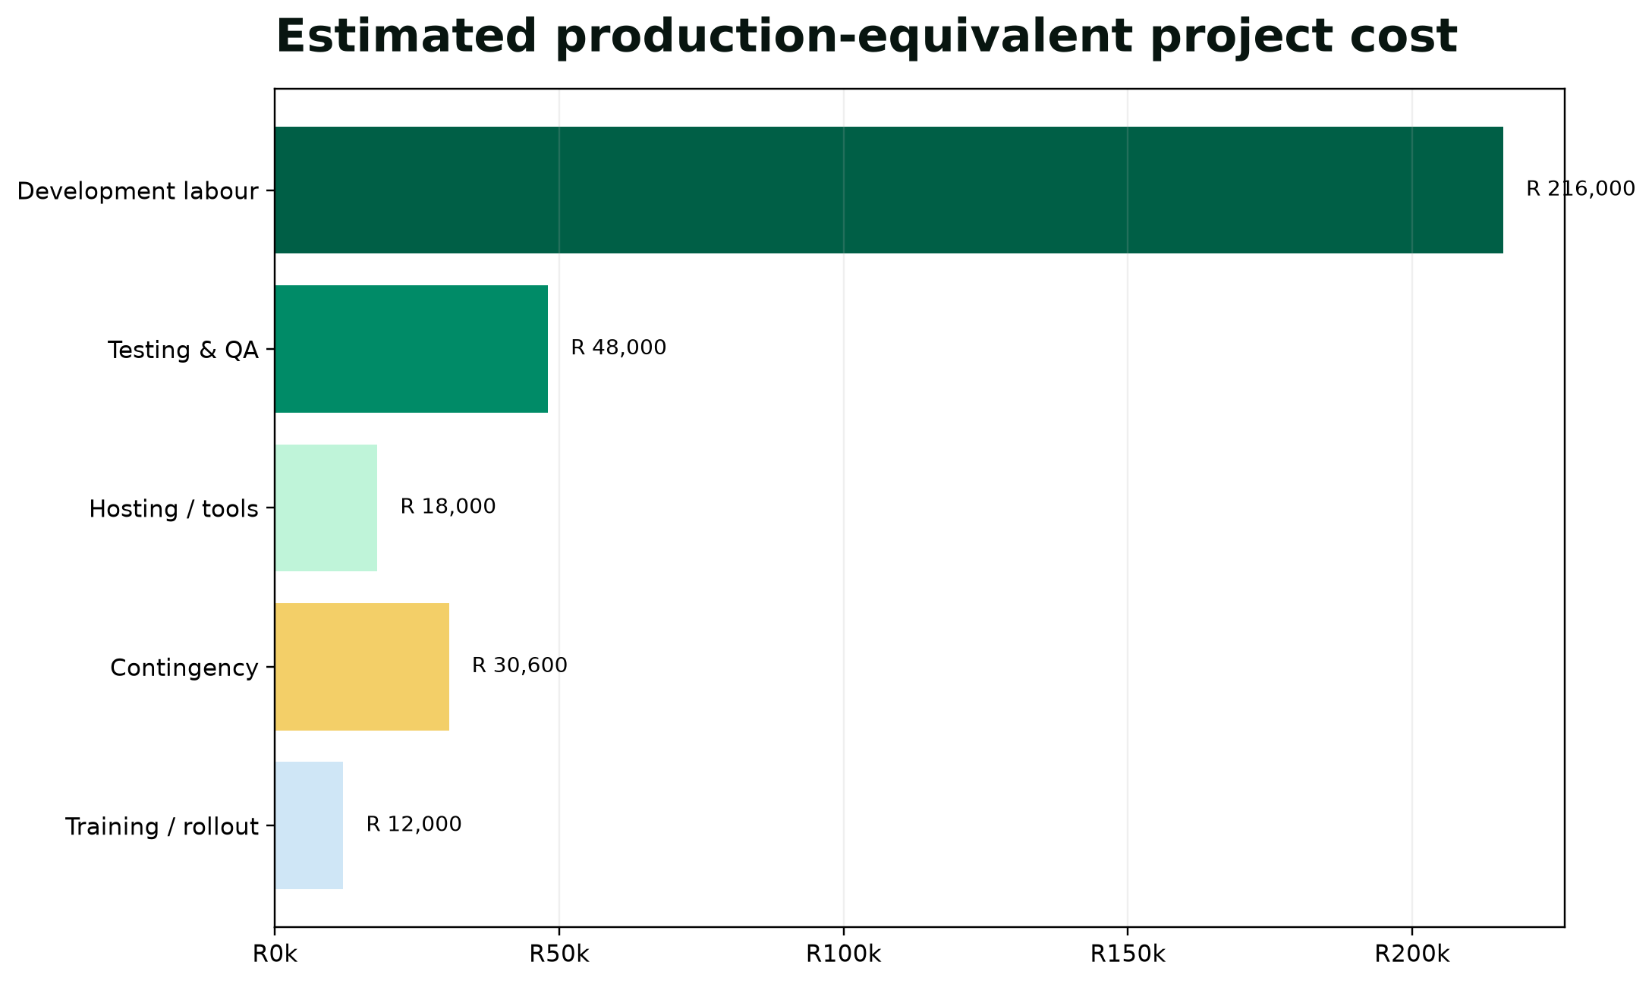
Figure 19. Production-equivalent project cost by category.
Table 46. Bottom-up cost estimate
Work package | Basis | Amount (ZAR)
Planning and analysis | 240 hours × R300/hour | 72,000
UX and frontend | 240 hours × R300/hour | 72,000
Backend and database | 240 hours × R300/hour | 72,000
Testing and security | 160 hours × R300/hour | 48,000
Hosting, domain, backups and tools | Pilot allowance | 18,000
Training and rollout | Documentation and two sessions | 12,000
Contingency | 10% of labour and operating baseline | 30,600
Total production-equivalent baseline |  | 324,600

The estimate uses a transparent bottom-up model so assumptions can be changed. The six students do not receive the notional labour cost; it represents the opportunity cost of 880 skilled hours at an illustrative blended rate. A production project would add payment-provider fees, legal advice, penetration testing, identity/accreditation integration and ongoing support. These are excluded until pilot scope and regulatory responsibilities are validated.

Economic Benefit Model
Table 47. Illustrative benefit and break-even assumptions
Assumption | Value | Interpretation
Verified placements in pilot year | 600 | Illustrative, not a forecast.
Average landlord success fee | R750 | Lower-friction hypothesis for validation.
Gross placement revenue | R450,000 | 600 × R750 before tax and operating cost.
Annual platform operating cost | R150,000 | Hosting, support, verification and monitoring allowance.
Contribution before development recovery | R300,000 | Revenue less operating allowance.
Indicative break-even | Approximately 13 months | R324,600 / R300,000 × 12; excludes finance and tax.

Interpretation caution
This is an academic feasibility model, not an investment forecast. Placement volume, pricing, VAT, payment costs, bad debt, verification labour and compliance costs must be validated before any commercial decision.

OUTPUTS

Reports and Sample Layouts
Operational reports convert transactional data into action without replacing the underlying audit trail.
Table 48. Sample booking pipeline report
Booking | Property | Student | Move-in | Rent | Deposit | Status | Response due
B-0001 | Braamfontein Studio Living | Demo Student | 17 Sep 2026 | R 6,100 | R 6,100 | Pending | Within 12 hours
B-0002 | Emerald House Hatfield | Demo Student | 17 Sep 2026 | R 5,200 | R 5,200 | Deposit held | Not applicable
B-0003 | Durban North Student Lofts | Example Student | 01 Oct 2026 | R 4,550 | R 3,000 | Completed | Not applicable

Table 49. Sample property assurance report
Property | Landlord verified | Property verified | NSFAS | Instant Book | Rooms | Rating
Emerald House Hatfield | Yes | Yes | Yes | Yes | 8 | 4.8
Braamfontein Studio Living | Yes | Yes | Yes | No | 4 | 4.6
Durban North Student Lofts | Yes | Yes | No | Yes | 11 | 4.7
Mowbray Campus Rooms | Yes | Yes | Yes | No | 6 | 4.5

The administrator-only report centre now generates current booking pipeline, property assurance and recent audit reports. Each report can be printed or saved as PDF through the browser and exported as CSV with spreadsheet-formula injection protection. The page is server-authorized, escapes dynamic HTML, and remains responsive by keeping wide tables inside horizontally scrollable regions on small screens. Future releases can add date, city, institution, landlord and status filters plus privacy-safe aggregation.

ROADMAP

Future Scope and Enhancement
Future development should deepen assurance and integration only after the MVP is validated with students, landlords, institutions and compliance specialists.
Table 50. Prioritized roadmap
Horizon | Enhancement | Reason / dependency
Next release | Property creation/edit forms and complete media upload | Allows landlords to manage inventory without seeded SQL; requires moderation workflow.
Next release | Email/SMS notification adapter and overdue-response escalation | Makes the 12-hour service promise operational; requires provider and consent.
Pilot | Regulated payment-service integration with webhook reconciliation | Replaces simulator; requires legal, financial and security approval.
Pilot | Institution/NSFAS accreditation verification interface | Reduces manual evidence; requires official partnership/API.
Pilot | Digital lease and move-in inspection checklist | Creates stronger condition and consent evidence; requires legal template review.
Pilot | Two-factor authentication for administrators and landlords | Hardens sensitive roles.
Scale | Geospatial distance and transport-time search | Improves proximity decisions; requires maps provider and cost control.
Scale | Availability calendar, waitlist and duplicate-booking prevention | Improves multi-room inventory accuracy.
Scale | Fraud analytics and anomaly review | Prioritizes suspicious accounts without automatic unfair exclusion.
Scale | Native mobile app and offline viewing | Supports low-connectivity users after web workflow stabilizes.

Maintenance and Configuration Management
Table 51. Maintenance plan
Activity | Frequency / trigger | Owner | Evidence
Dependency and platform review | Monthly and before release | Backend lead | Supported PHP/MySQL matrix and change ticket
Security patching | Critical advisory or monthly window | Security lead | Patch record and regression result
Database backup verification | Daily backup; quarterly restore | Database lead | Restore log and recovery timing
Access review | Monthly and staff/role change | Administrator | Account/role review sign-off
Audit review | Weekly in pilot | Administrator | Reviewed anomalies and actions
Retention deletion | Monthly and purpose end | Privacy owner | Deletion log without retained sensitive content
Regression test | Every release | QA lead | Signed execution register
Documentation update | Every accepted change | Document owner | Version, change summary and traceability update

REFERENCES

Bibliography and Source Register
Sources are selected for relevance to the South African context, the comparator workflow and the implemented security controls.
[1] Department of Higher Education and Training. Report on the Ministerial Committee for the Review of the Provision of Student Housing at South African Universities (2011). https://www.dhet.gov.za/ResearchNew/39.%20Student%20housing%20at%20South%20African%20universities.pdf
[2] Department of Higher Education and Training. Student Housing Symposium keynote address (2016). https://www.dhet.gov.za/SiteAssets/Minister%20Speech%202016/Student%20Housing%20Symposium%20Minister%20Speech%2021%20July%202016.pdf
[3] National Student Financial Aid Scheme. Registering accommodation properties and student accommodation guidance. https://nsfas.org.za/content/studentacom.html
[4] DigsConnect. Student accommodation marketplace and how-it-works pages (accessed August 2026). https://www.digsconnect.com/
[5] DigsConnect. Terms and conditions, booking process and landlord facilitation fee (accessed August 2026). https://www.digsconnect.com/terms-and-conditions/
[6] Republic of South Africa. Protection of Personal Information Act 4 of 2013. https://www.justice.gov.za/legislation/acts/2013-004.pdf
[7] PHP Documentation. password_hash and password_verify guidance. https://www.php.net/manual/en/function.password-hash.php
[8] PHP Documentation. PDO::prepare and parameter binding. https://www.php.net/manual/en/pdo.prepare.php
[9] OWASP Cheat Sheet Series. Authentication and Session Management guidance. https://cheatsheetseries.owasp.org/cheatsheets/Authentication_Cheat_Sheet.html
Local project sources: IT PROJECT GUIDELINES SEMESTER 2 2026.pdf; IT Project Group List Submission.eml; IT Project 700.xlsx; group 55 files/Phase 1.docx; group 55 files/Emergex pitch.docx; and the complete 20 August 2026 IT Project 600/700 information-session recording/transcript. These files define the rubric, administration, group identity, original concept direction and final presentation controls.

APPENDIX A

Glossary
The glossary standardizes terminology used in the interface, database and assessment presentation.
Table 52. Glossary
Term | Definition
Accreditation | A formal determination by an authorized body that accommodation meets relevant requirements.
Audit log | A timestamped record of a security- or business-relevant action.
Authentication | Verification that a user controls the credentials of an account.
Authorization | Decision about what an authenticated user may access or change.
Booking | A request or reservation linking one student to one property and move-in date.
CSRF token | Unpredictable session value used to reject forged state-changing requests.
Data integrity | Accuracy, consistency and valid relationships throughout the data lifecycle.
Demo data | Artificial information safe for academic testing and presentation.
Escrow simulator | A state model that demonstrates hold and release without processing real funds.
Foreign key | Database constraint connecting a child record to an existing parent.
Instant Book | Booking path that starts approved for an eligible verified property.
MIME type | Server-inspected description of file content used in upload validation.
Normalization | Organization of relational data to reduce duplication and anomalies.
Personal information | Information relating to an identifiable person as governed by POPIA.
Prepared statement | SQL template in which values are bound separately from query structure.
Property verification | Administrator review state required before a listing is published.
RBAC | Access control based on the user role and, where relevant, record ownership.
Response deadline | Timestamp 12 hours after a standard booking request is created.
Session | Server-maintained authenticated interaction associated with a hard-to-predict identifier.
Traceability | Link from a need or requirement to design, code and test evidence.
Transaction | Atomic group of database changes that commits together or rolls back together.
UAT | User acceptance testing against agreed business outcomes.
Visual evidence | Listing media categories such as walkthrough, floor plan and 360-degree tour.
XAMPP | Local package providing Apache, MariaDB/MySQL-compatible database and PHP on Windows.

APPENDIX B

Meeting and Review Templates
Recorded coordination supports fair contribution, supervisor visibility and timely issue resolution.
Table 53. Meeting minutes template
Field | Required entry
Meeting | Team / supervisor / integration / test review
Date, time and platform | Include MS Teams link or physical/online location
Chair and minute taker | Rotate across group members
Attendance | All invited members and apologies
Previous actions | Owner, due date and completed/open state
Progress by workstream | Evidence completed since last meeting
Decisions | Decision, rationale and approver
Risks/issues | Impact, response and escalation
New actions | Action, owner and due date
Next meeting | Confirmed date and expected evidence

Table 54. Change request template
Field | Description
Change ID and requester | Unique reference and person proposing change
Reason | Problem, feedback or evidence that triggers request
Affected requirements | Stable FR/NFR identifiers
Scope and design impact | Modules, data, interfaces and documents affected
Schedule/cost impact | Critical-path and resource effect
Security/privacy impact | Threat, personal data and compliance effect
Recommendation | Approve, reject, defer or request more evidence
Decision and approver | Timestamped outcome
Verification | Tests and documents updated after approval

APPENDIX C

Final Submission Checklist
The checklist is completed by the project lead and peer reviewer before the supervisor or Moodle submission.
Table 55. Submission quality gate
Check | Owner | Evidence / sign-off
Project title, group number, supervisor and all six members appear on the first pages. | Project lead
Phase scope matches the official deadline and rubric. | Business analyst
Table of contents and page numbers have been updated in Word. | Document owner
Every figure and table has a number, title and readable content. | Document reviewer
Functional/non-functional requirements trace to design and tests. | QA lead
Application installs from a clean XAMPP environment. | Deployment lead
All 32 runtime tests and the report/backup controls have current evidence. | QA lead
The administrator can generate reports, export CSV and print/save PDF. | Administrator
A current SQL backup exists and the guarded restore has been demonstrated. | Database lead
No real personal documents, secrets or payment data remain in the demo. | Security lead
Source URLs and bibliography are complete and human-readable. | Business analyst
All six members completed a timed live-demo rehearsal and can answer code/database/security questions. | Project lead
Supervisor approval was obtained before every member submitted the same package to Moodle. | Project lead
Final files are backed up and the submission email CCs required participants. | Project lead

